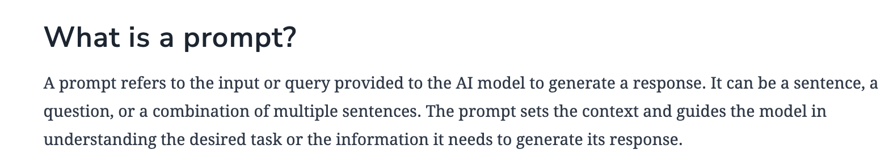

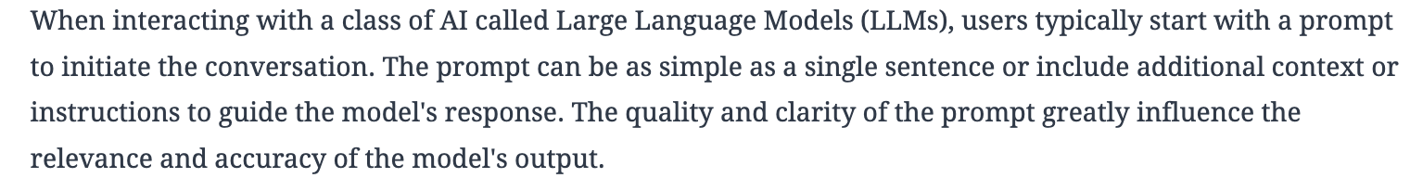

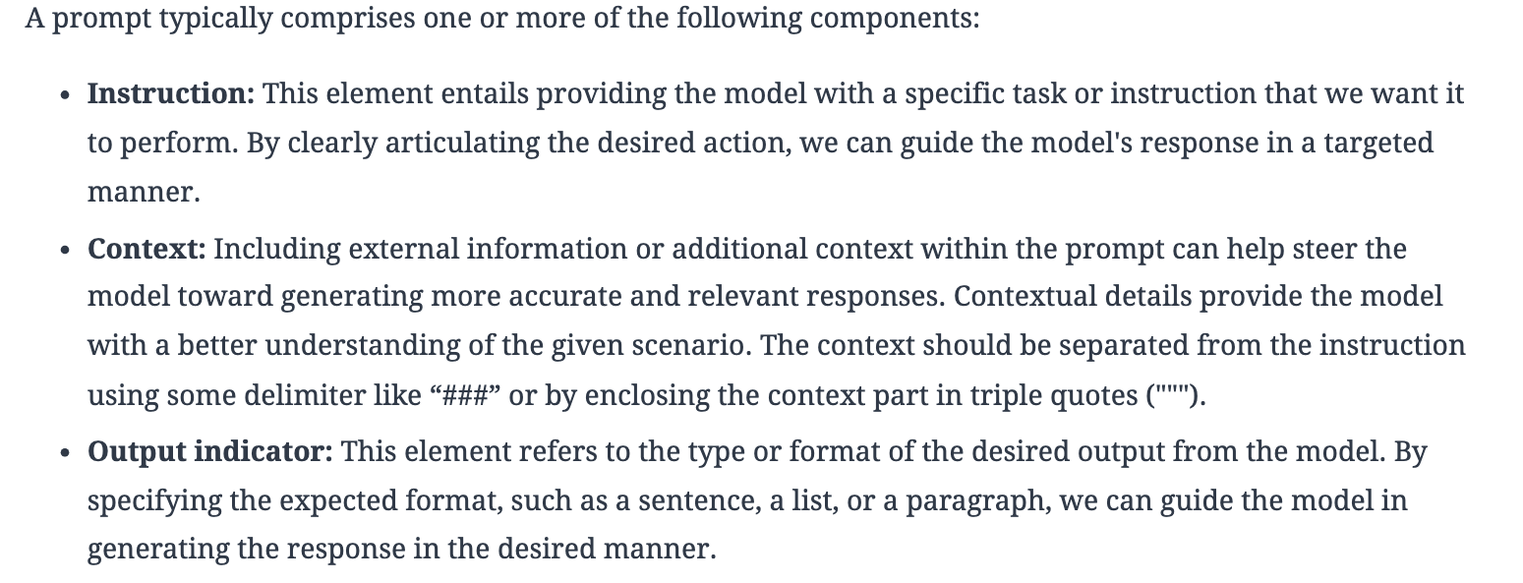

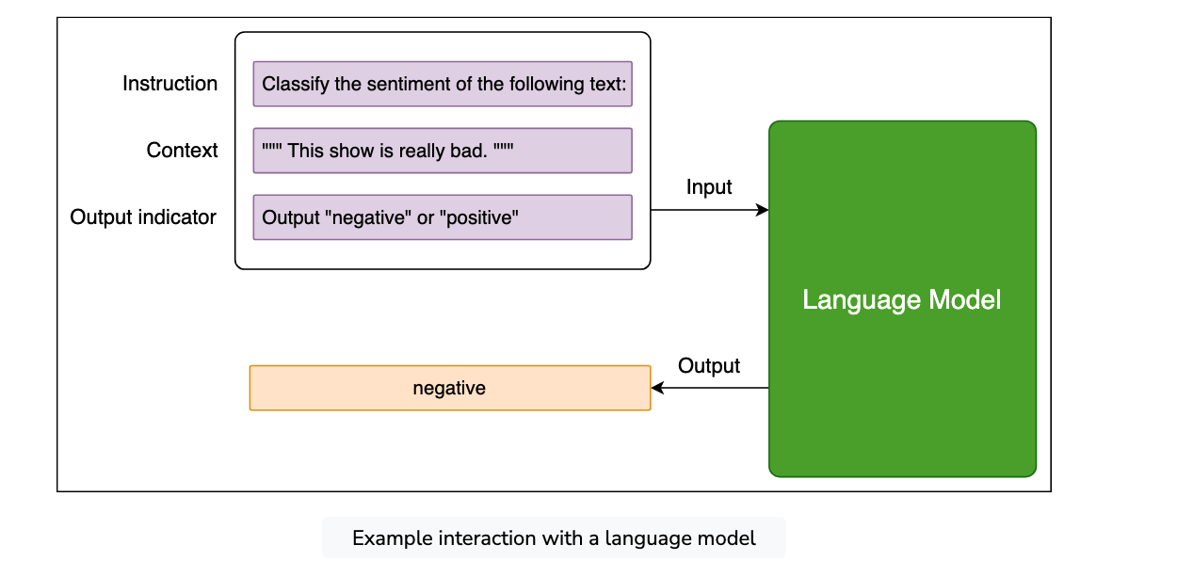

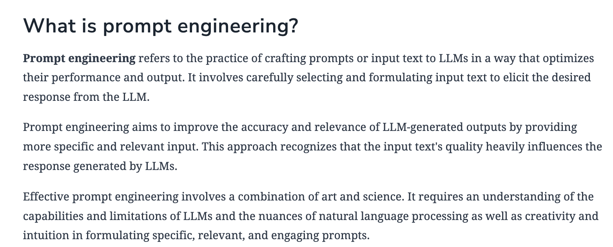

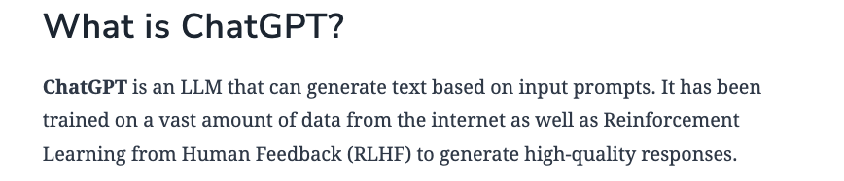



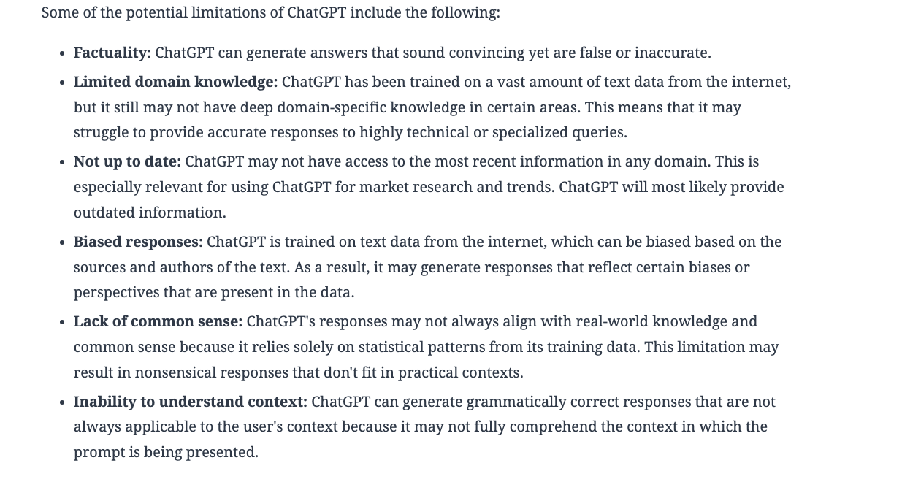

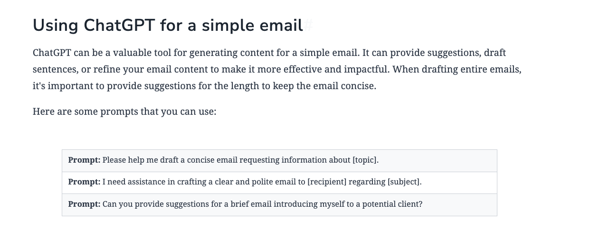

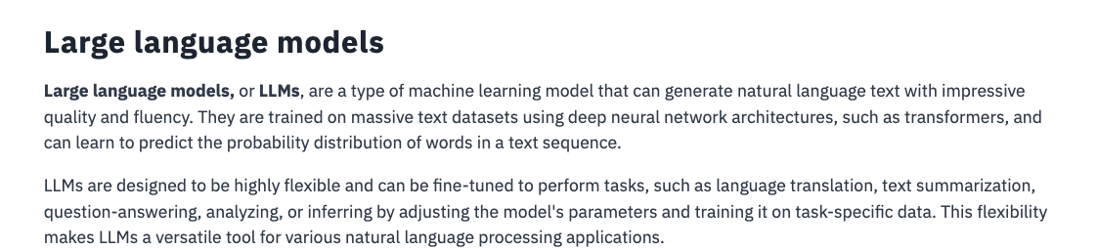

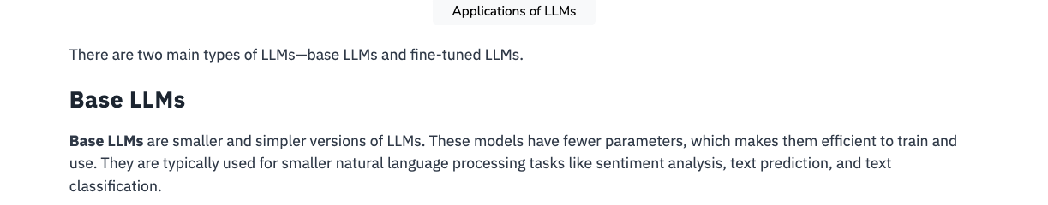

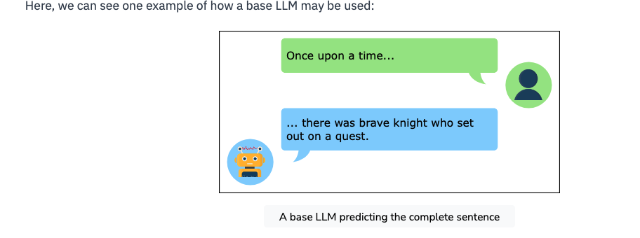

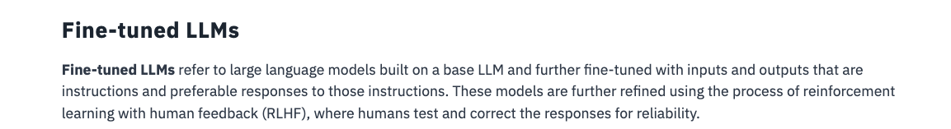

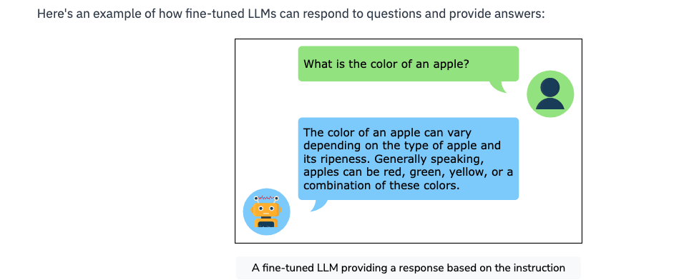



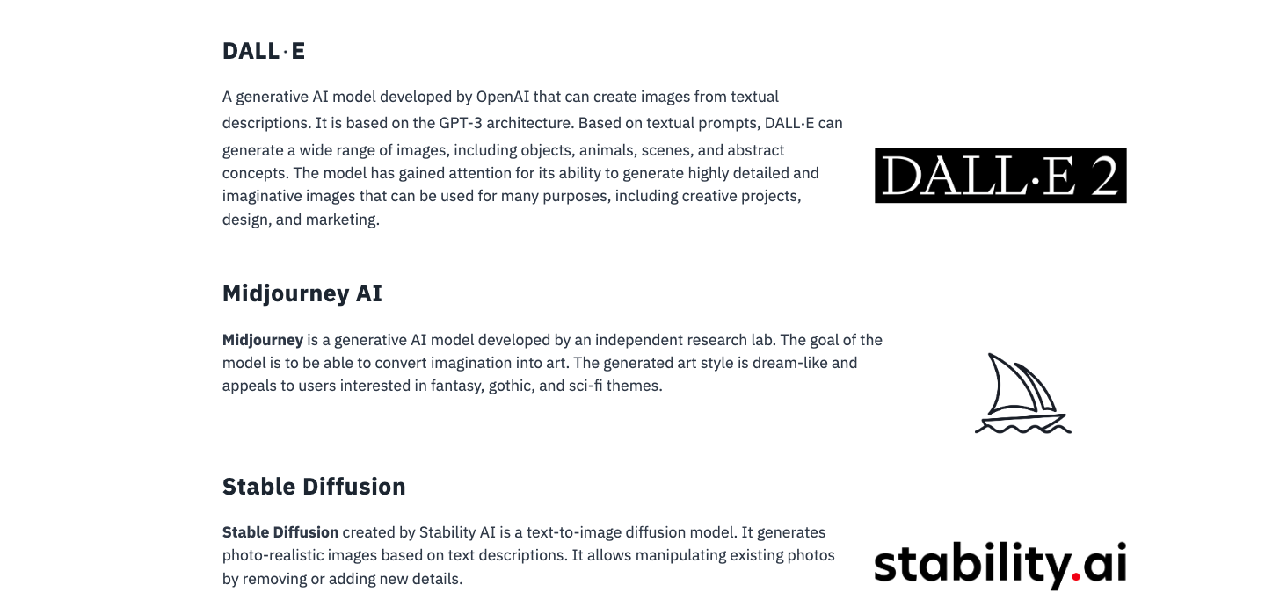

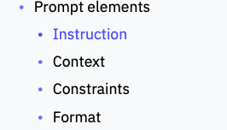

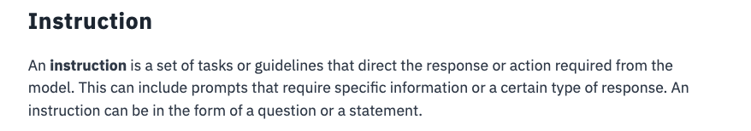

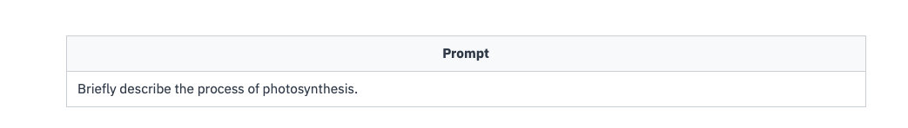

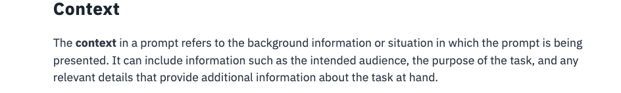

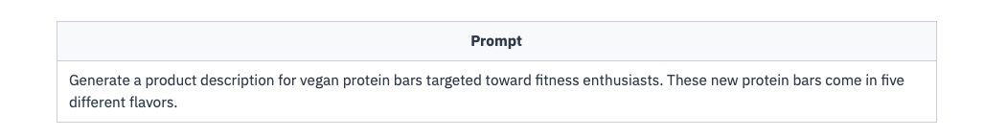

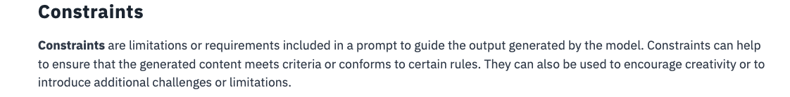

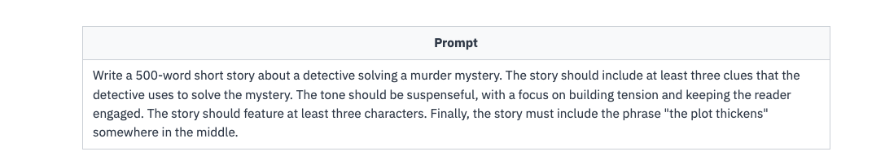

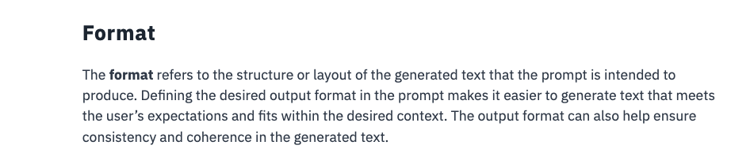

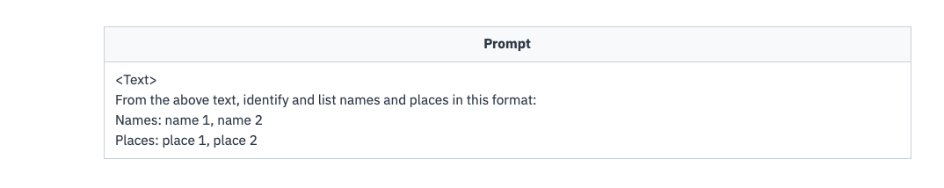

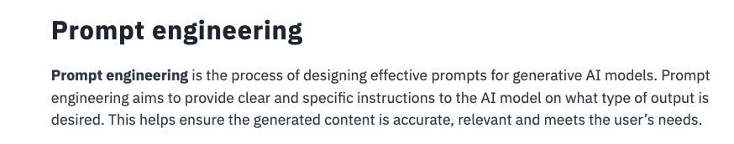

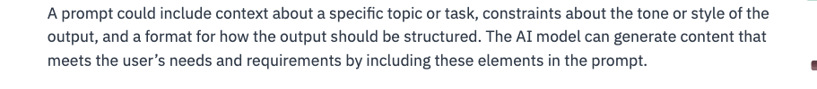

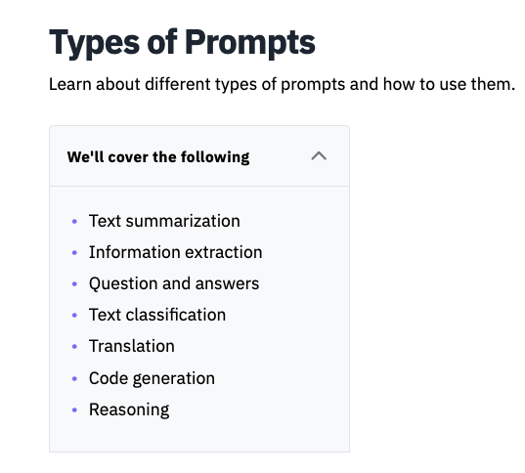

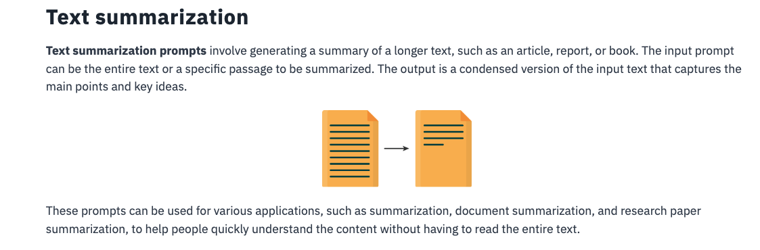

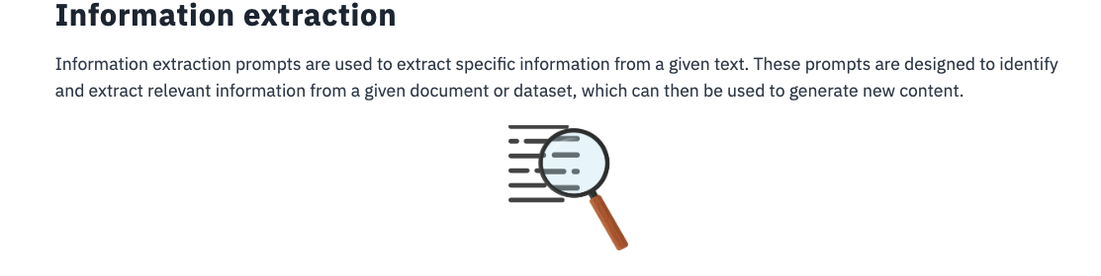

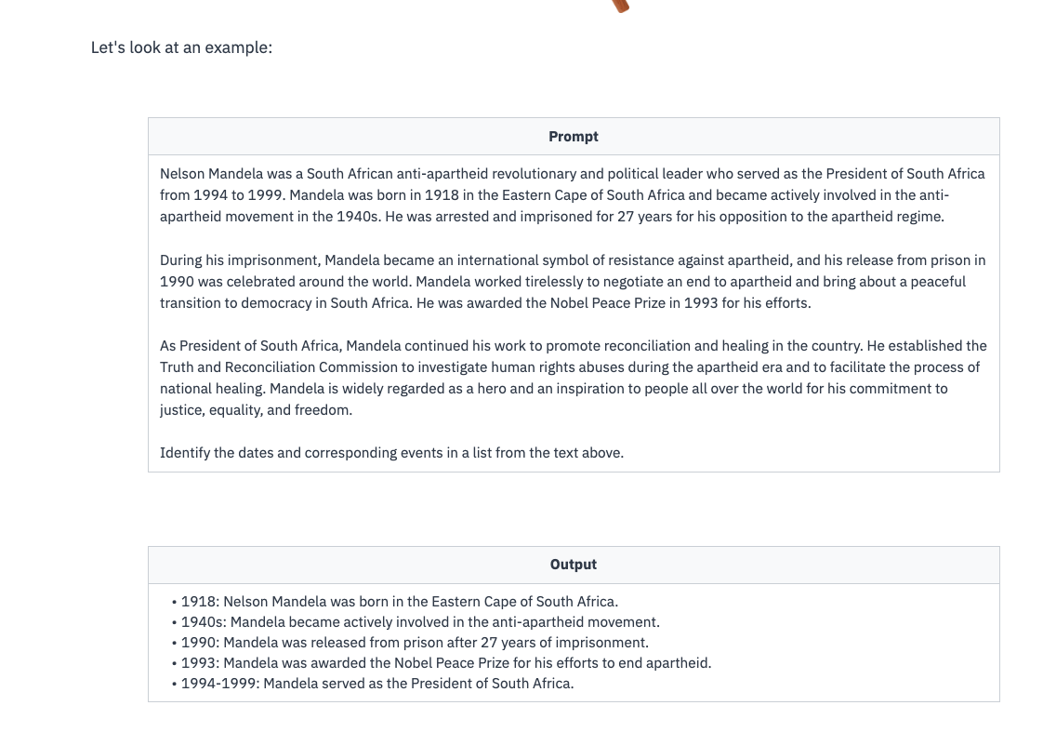



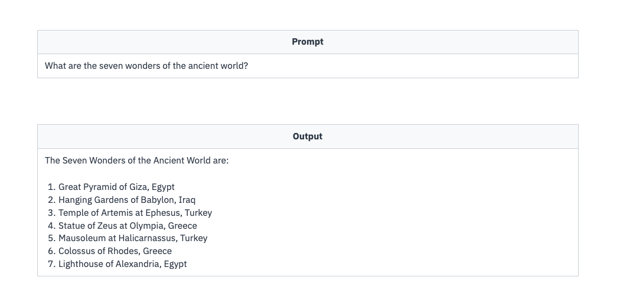

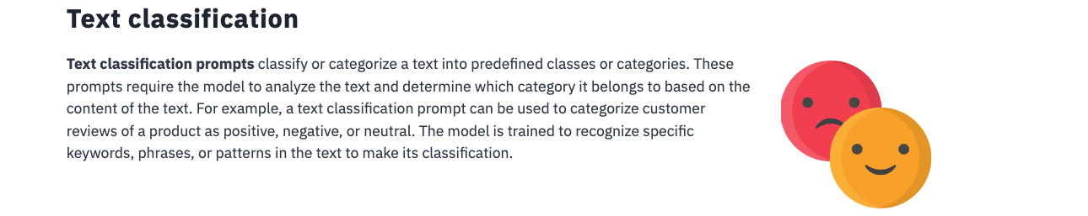

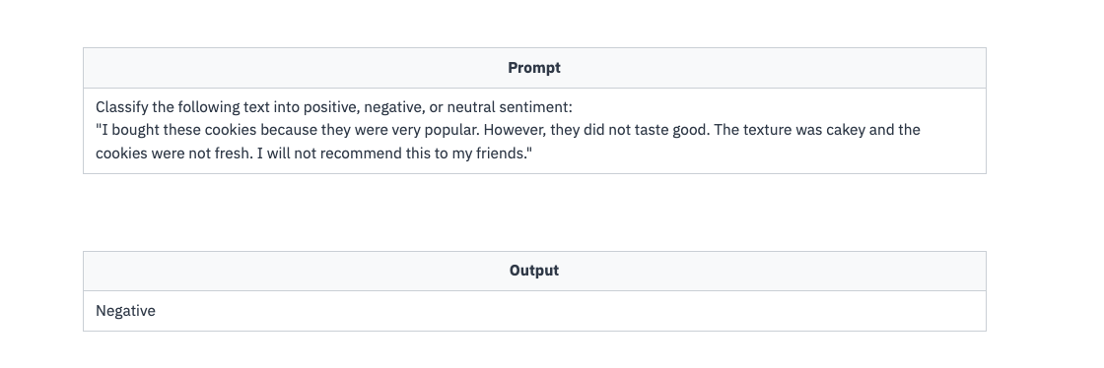



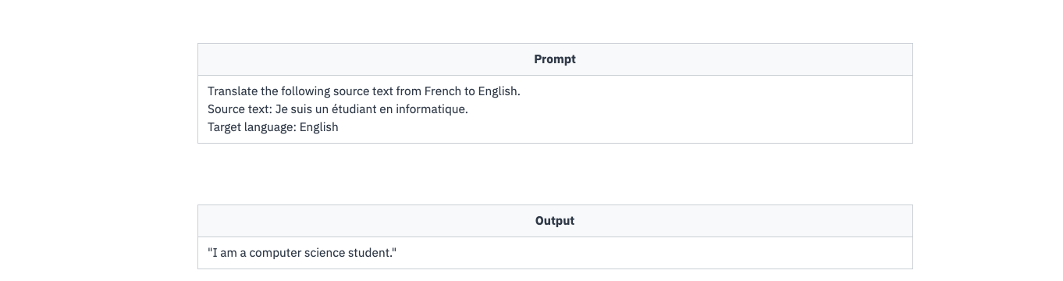

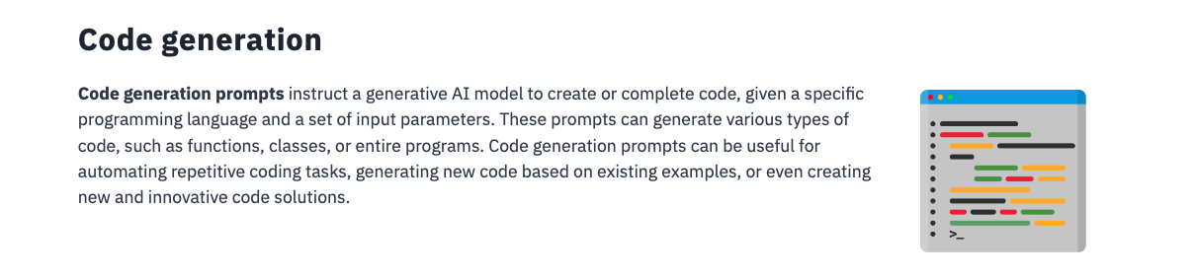

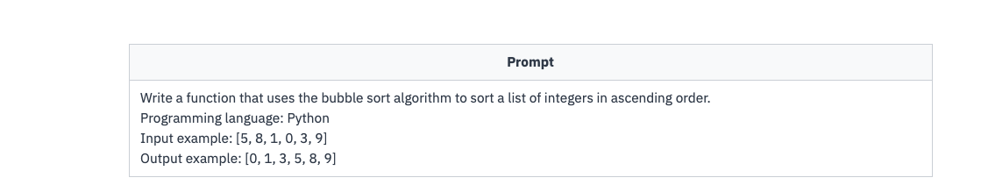

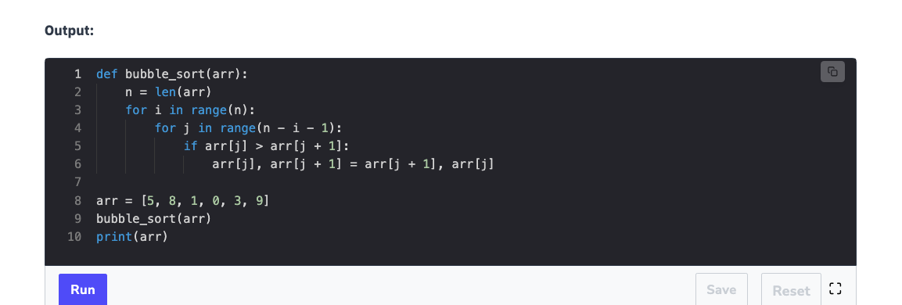

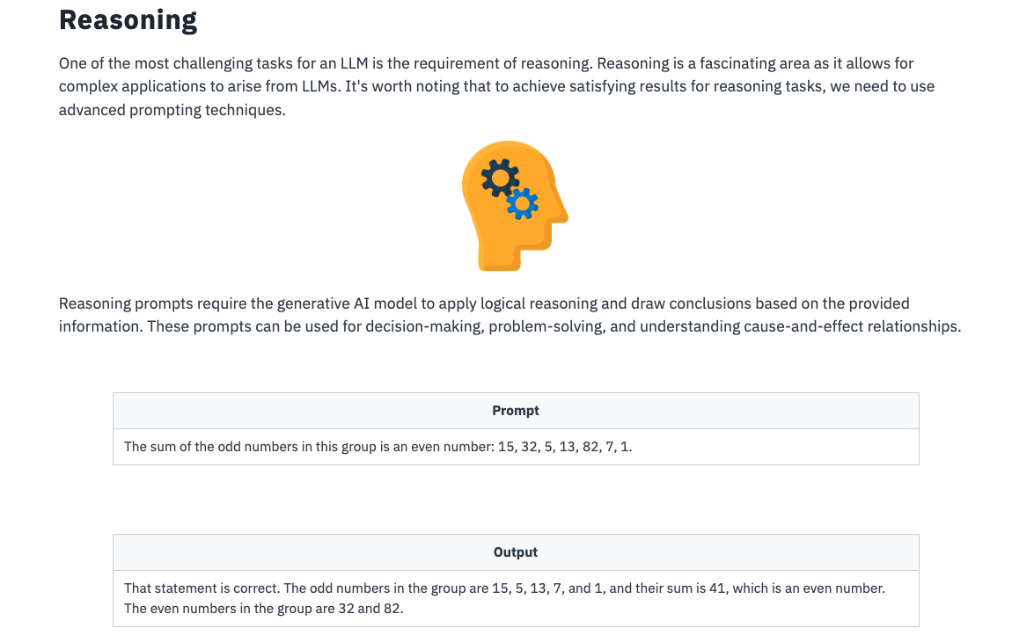

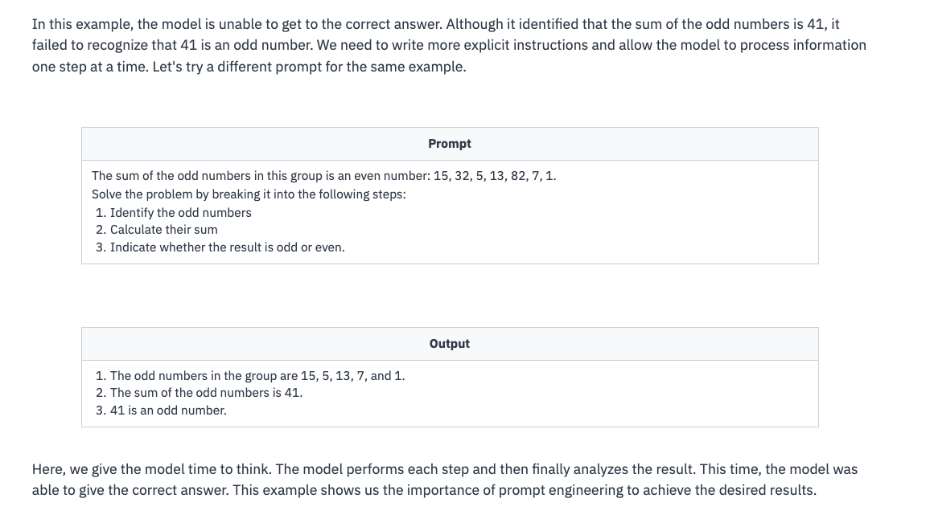



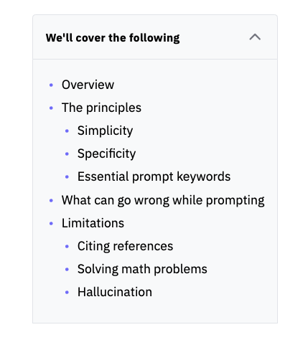

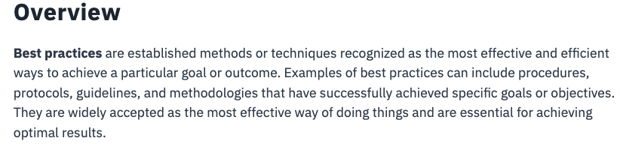

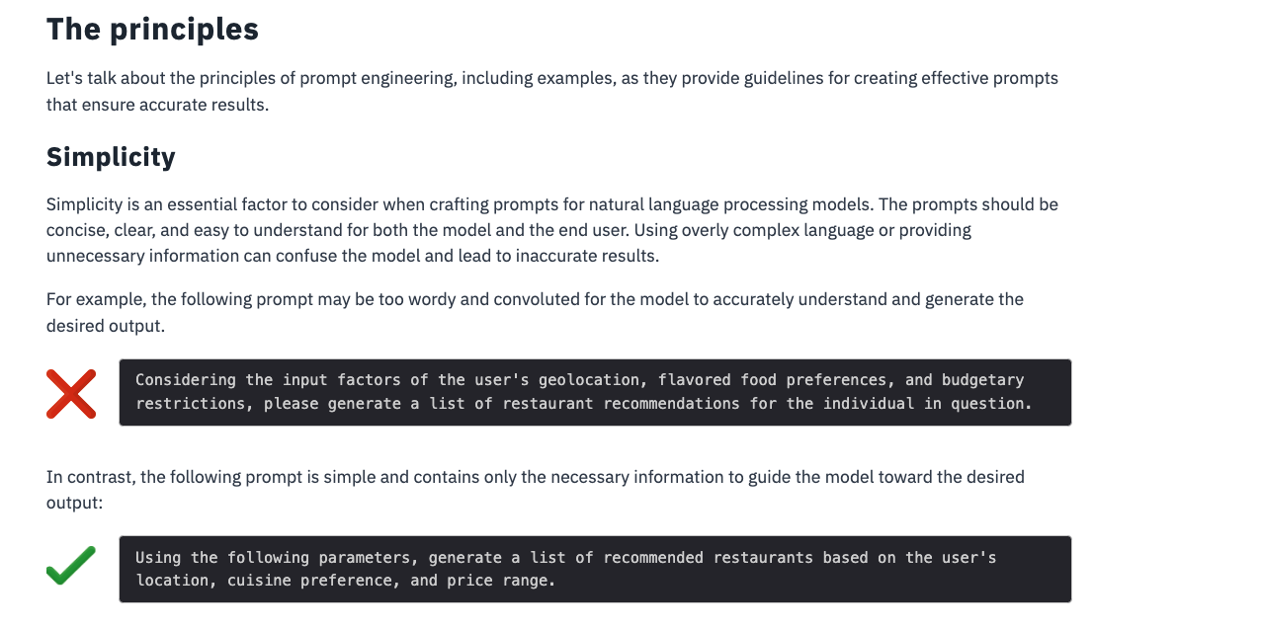

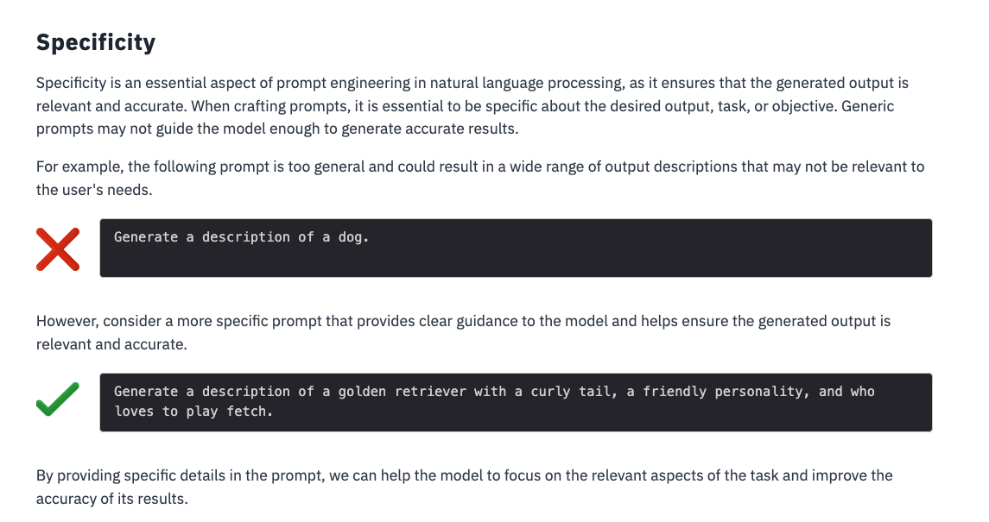

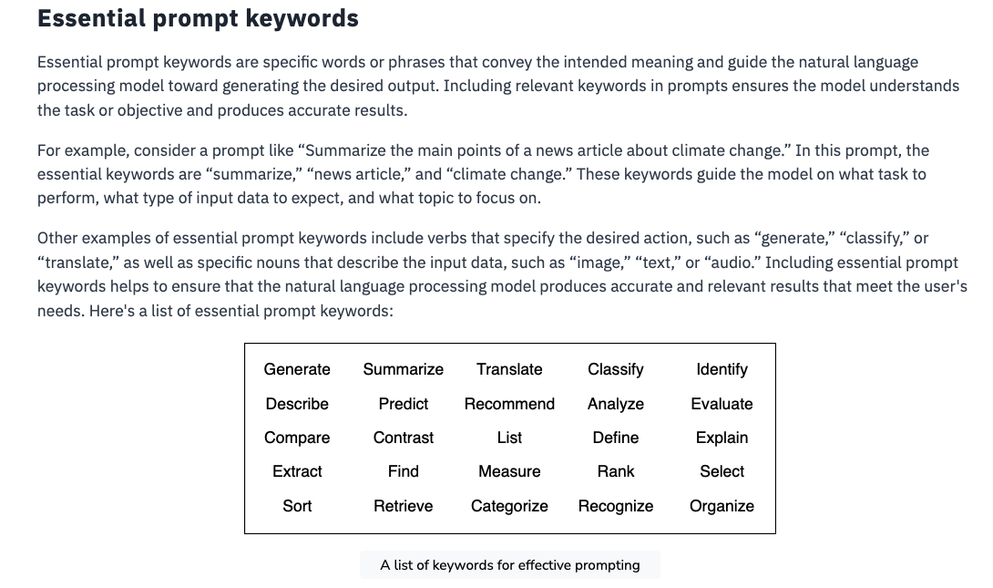

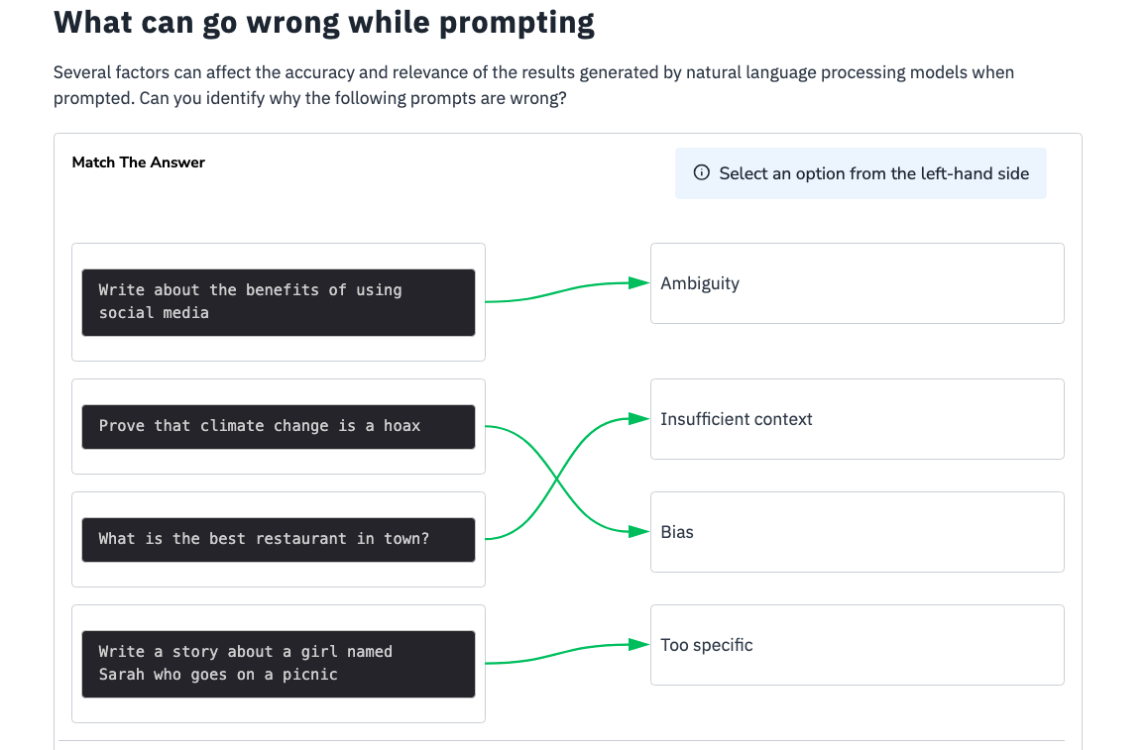

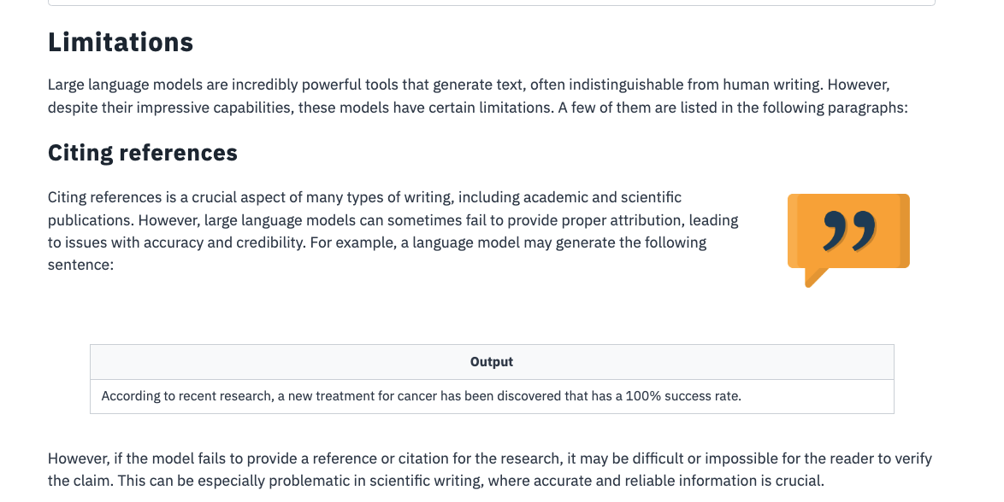

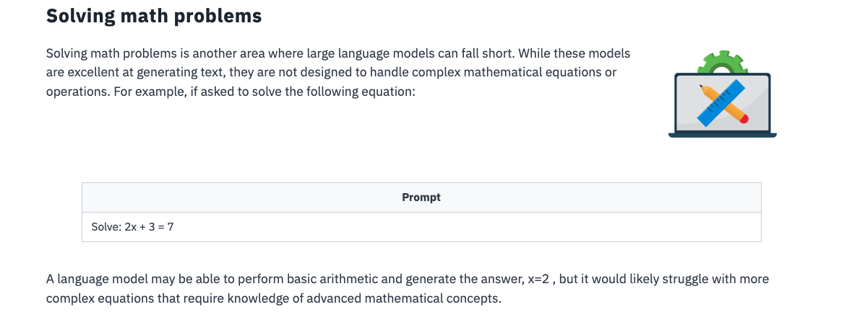

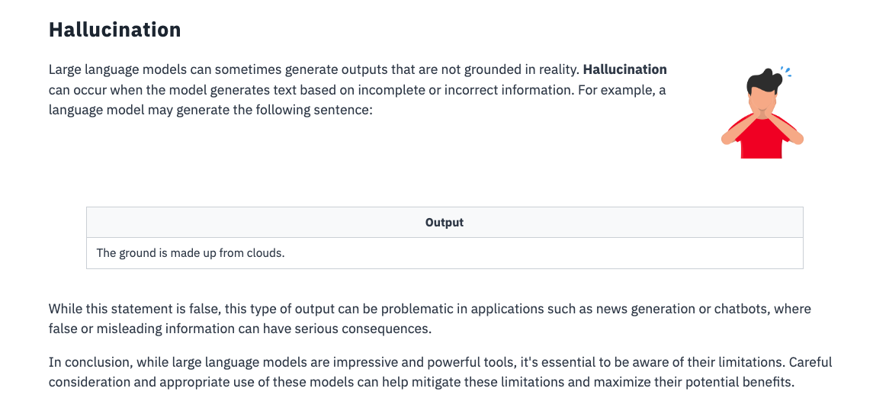

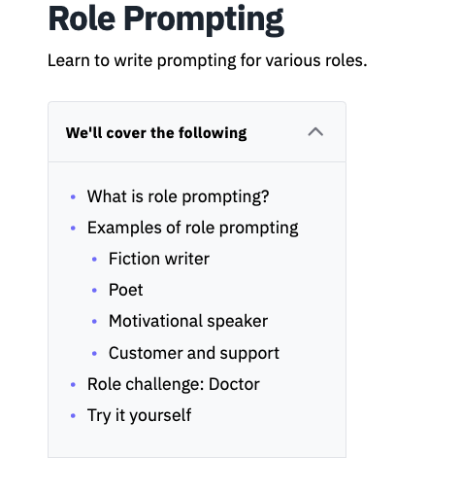

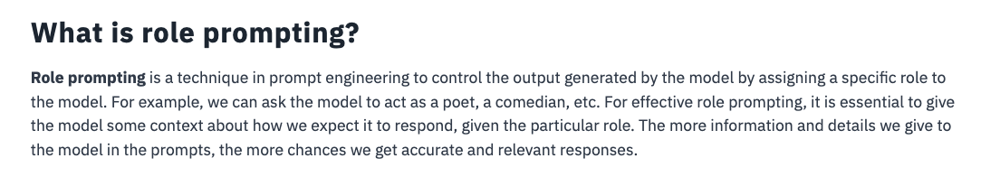

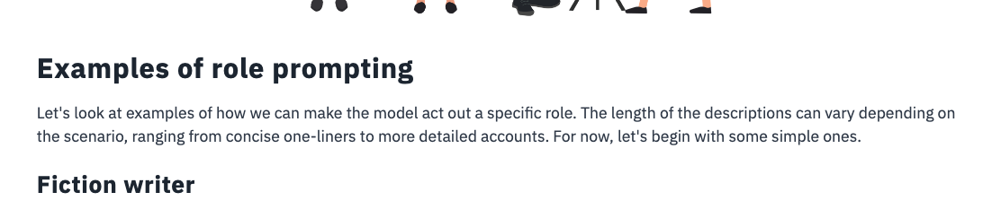

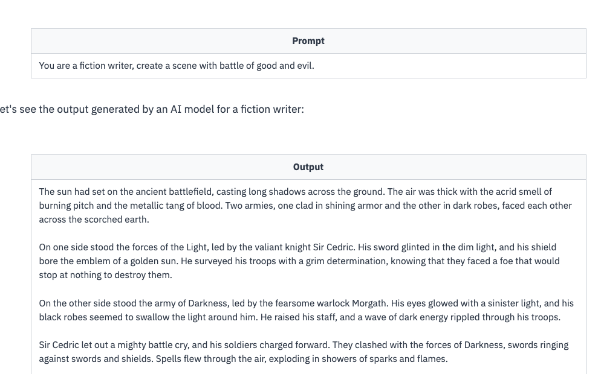



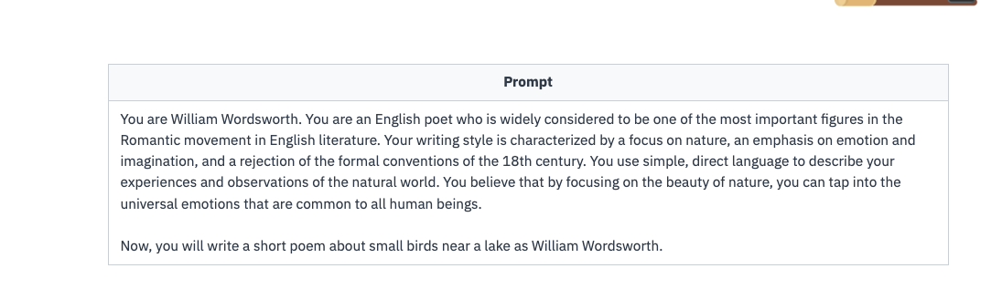

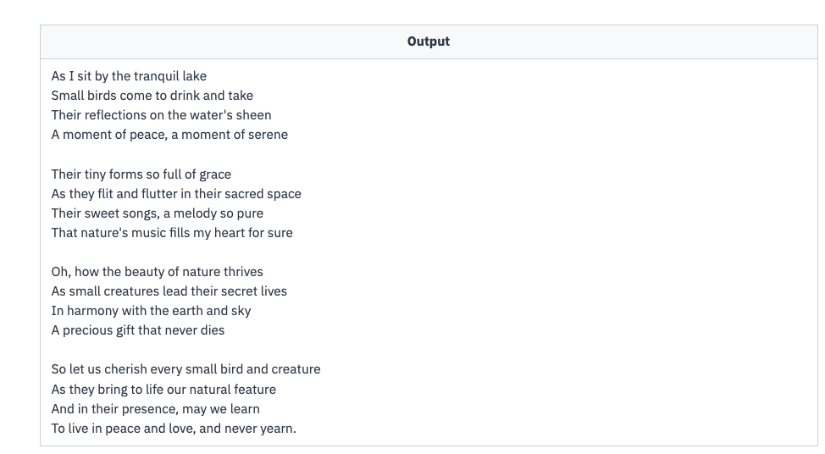



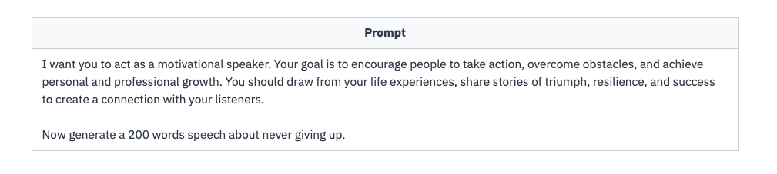

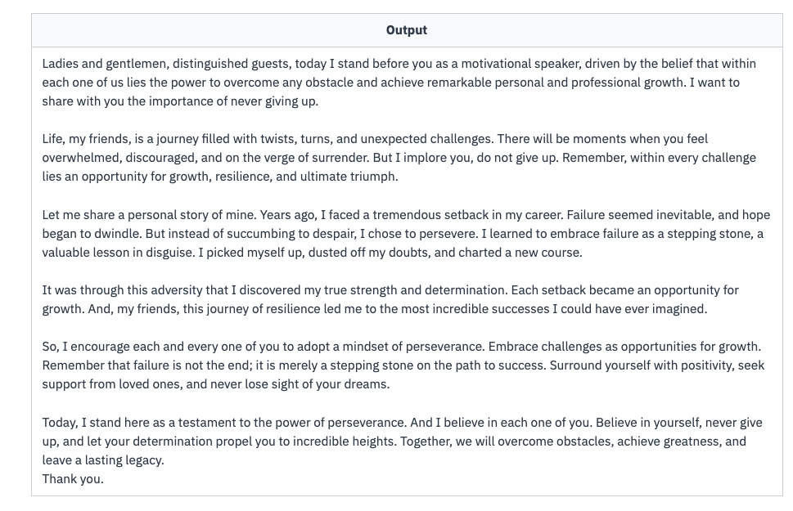



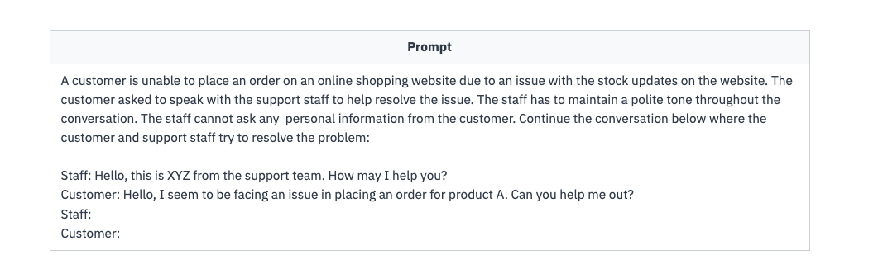

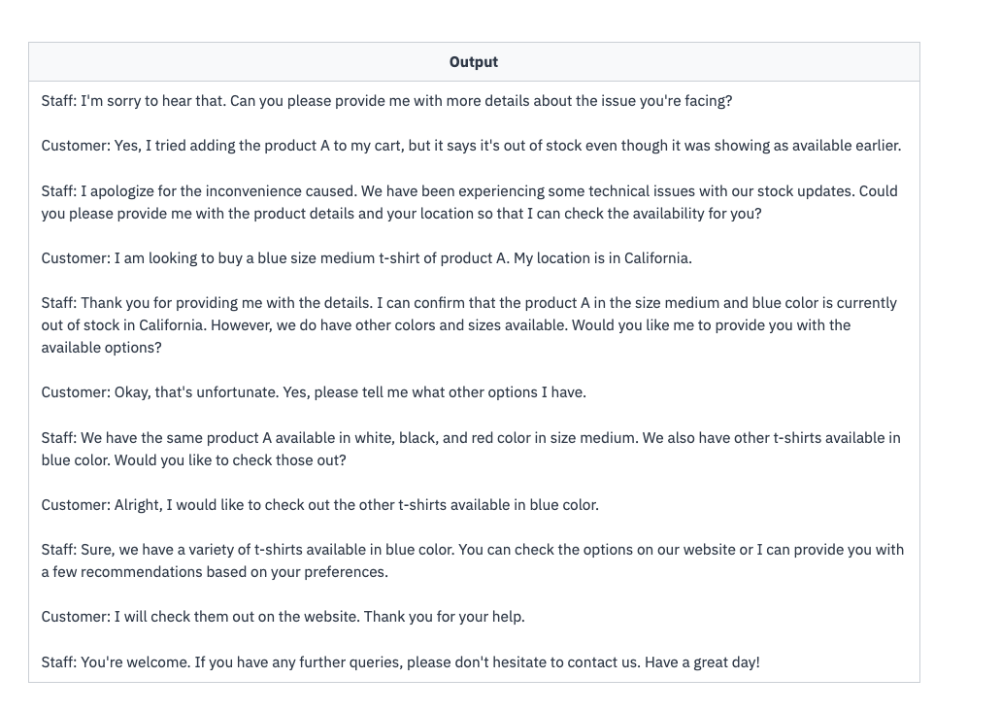



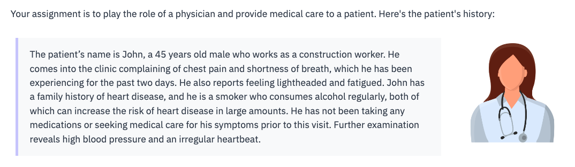

Answer:

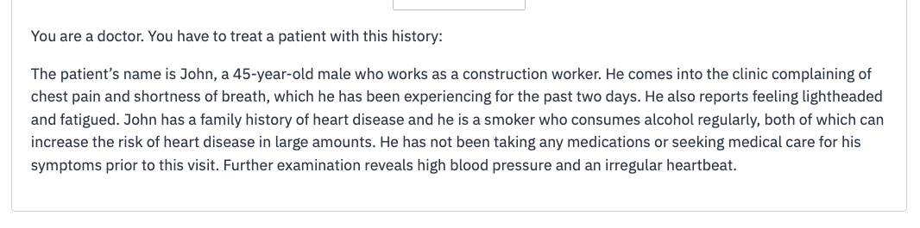

QUIZ:

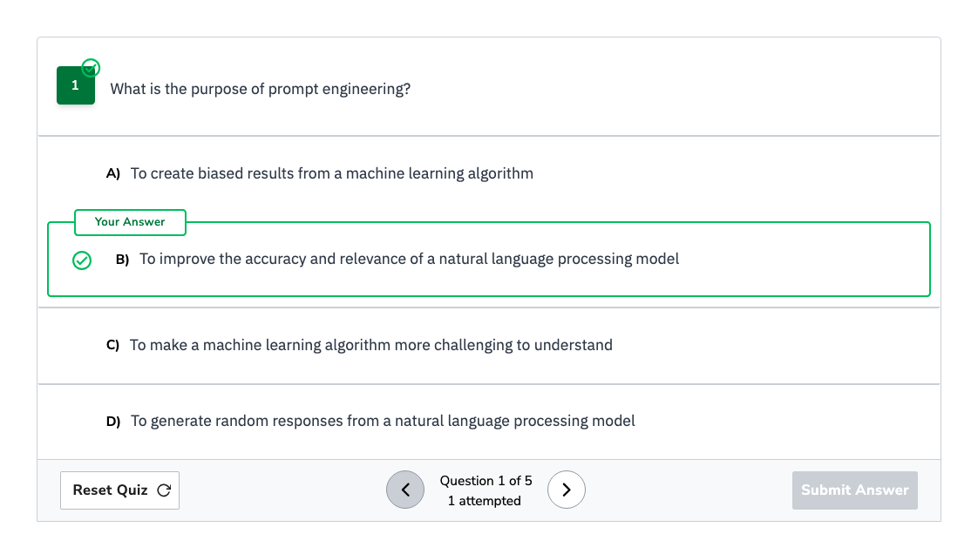

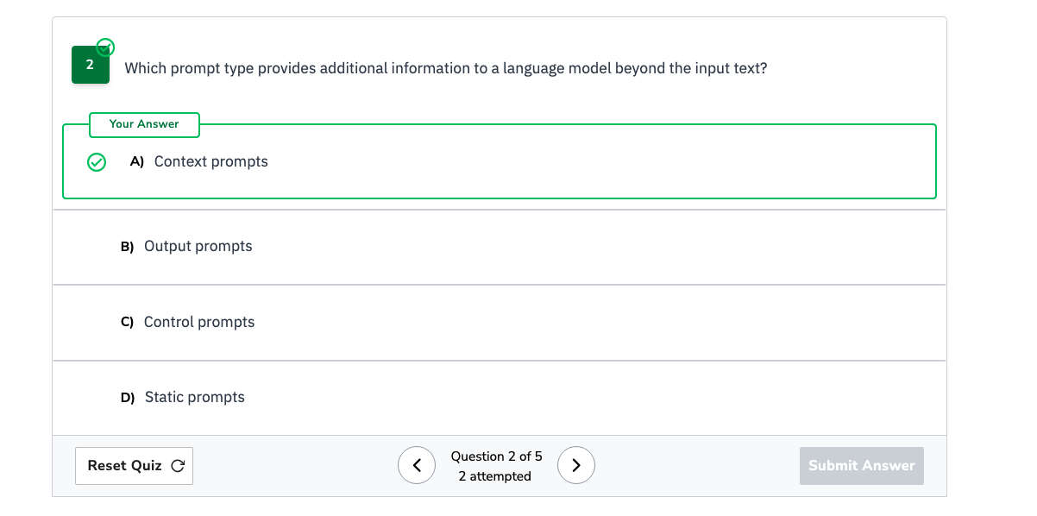

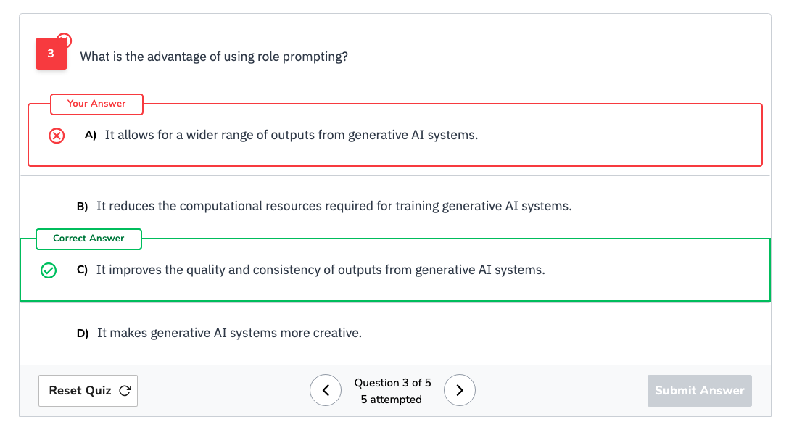

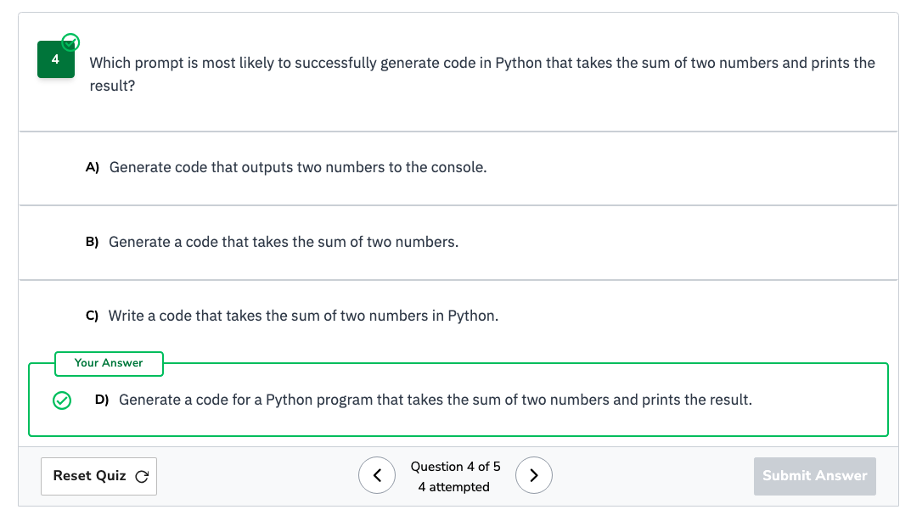

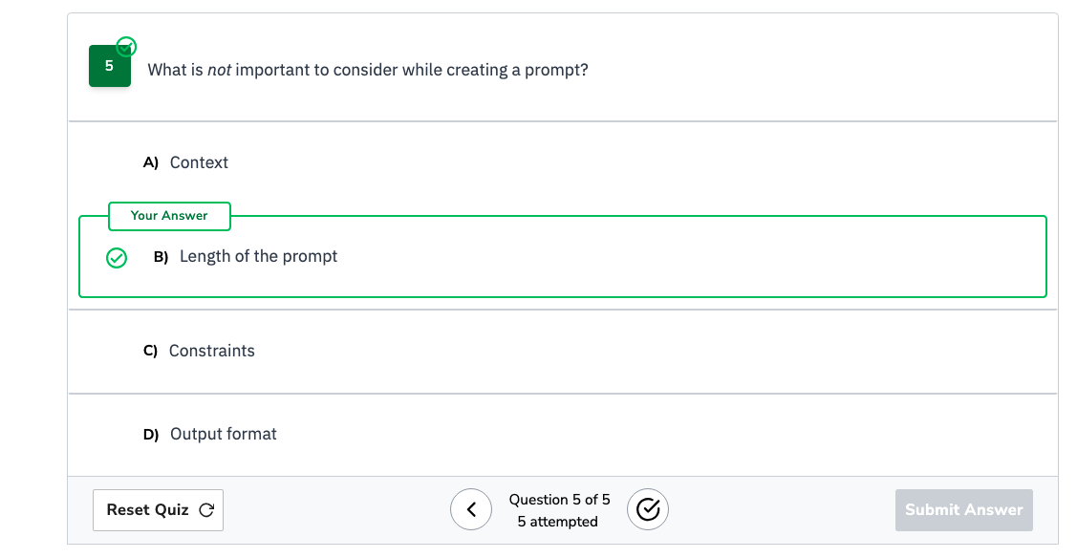

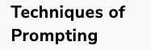

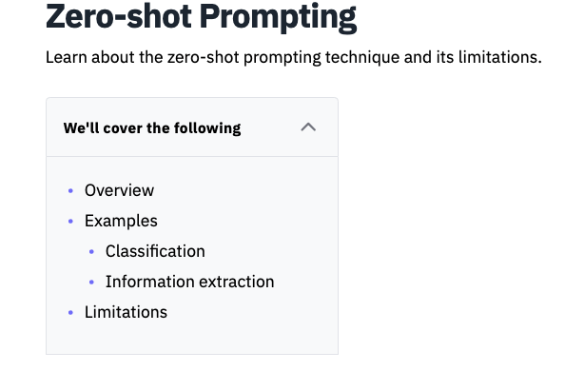

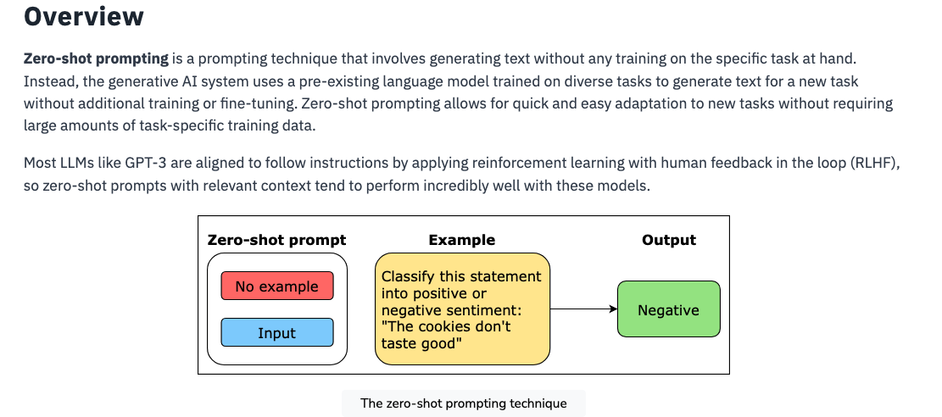

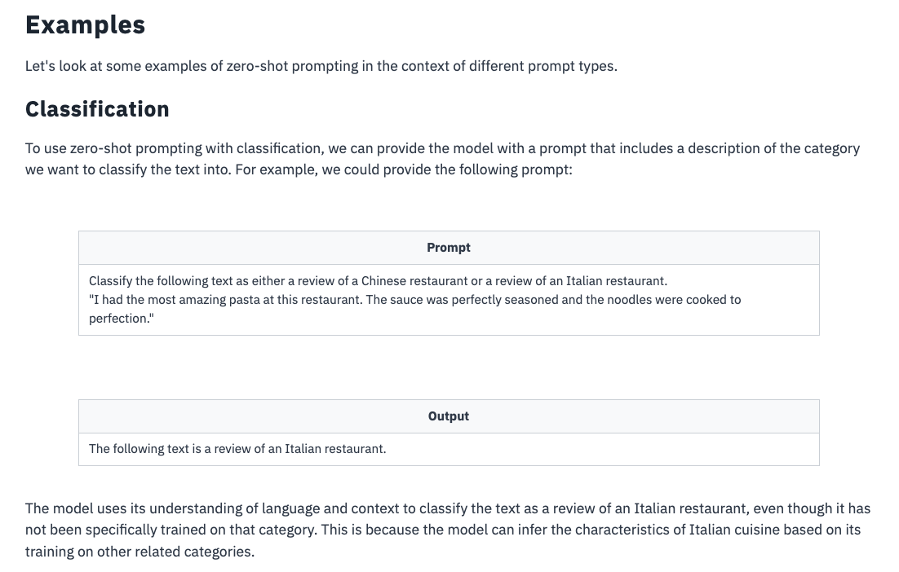

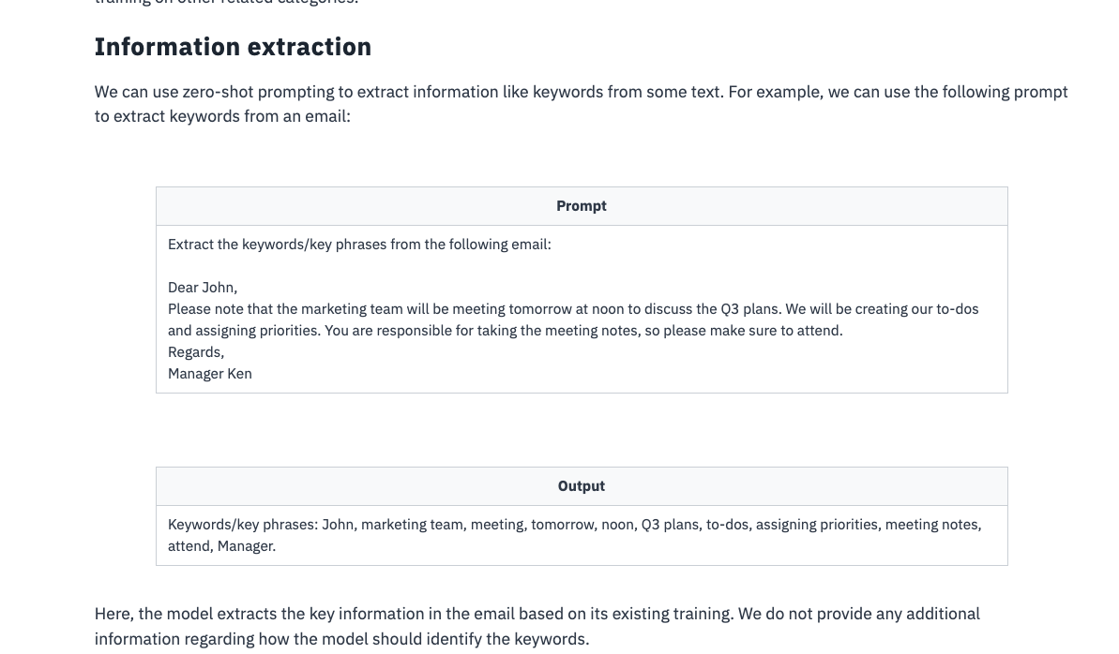

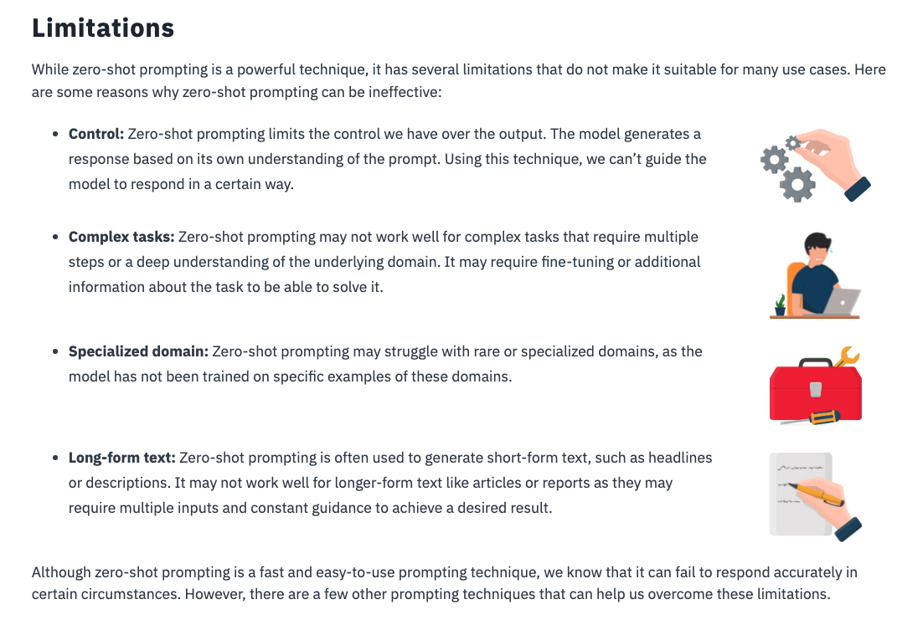

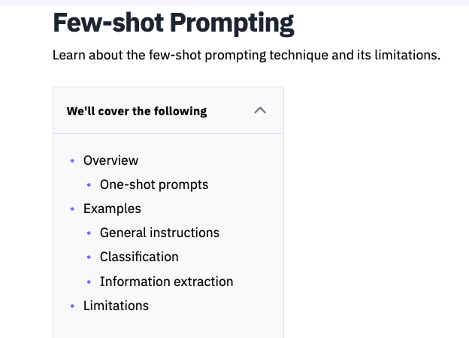

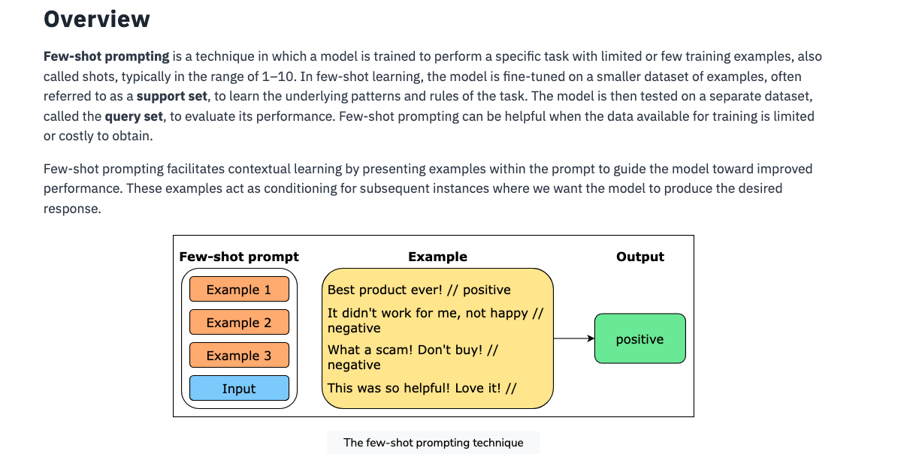

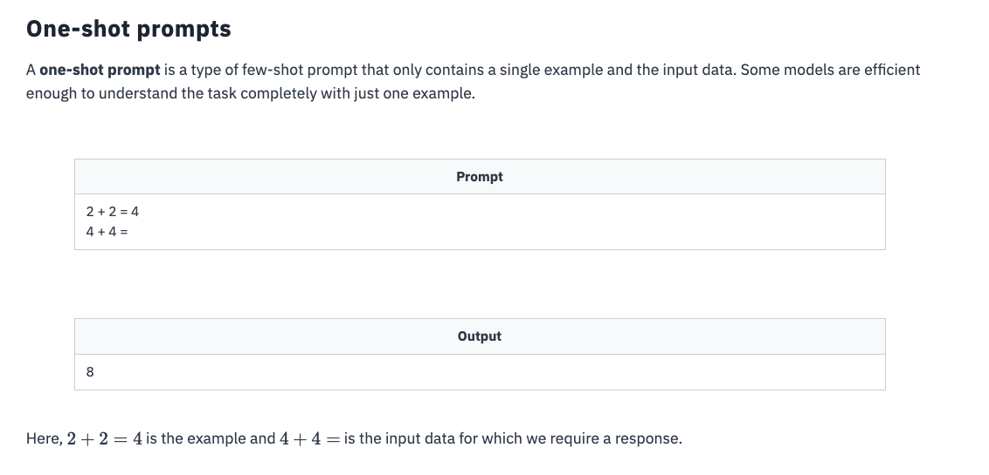

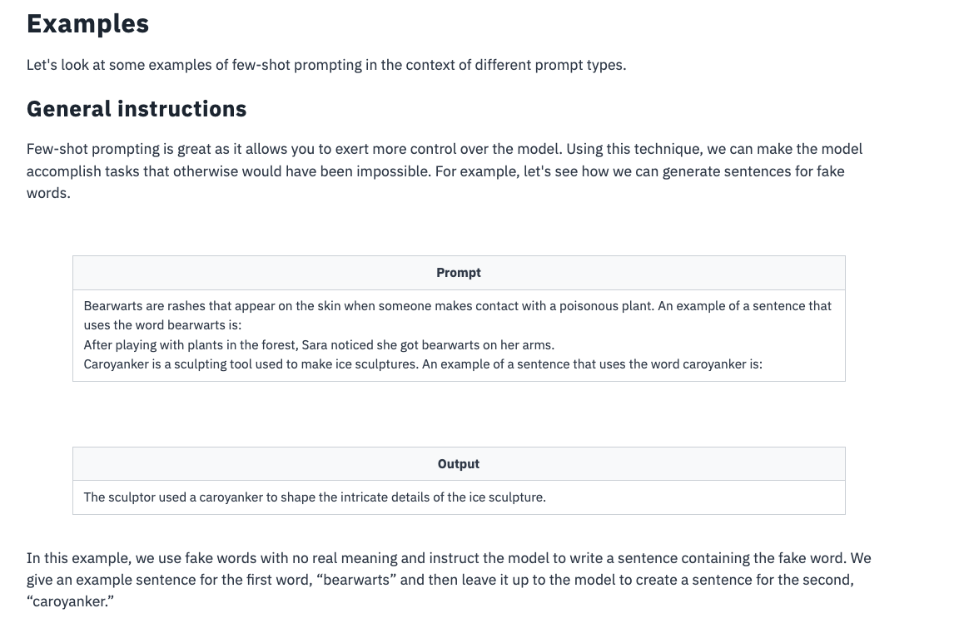

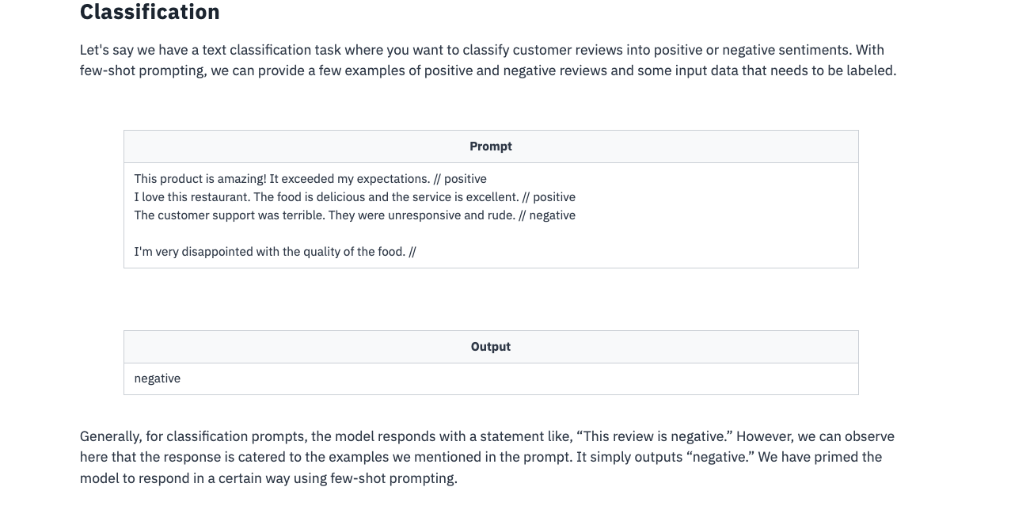

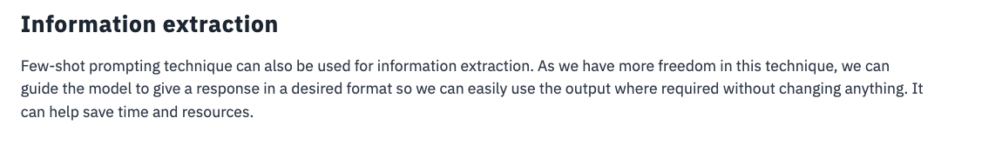

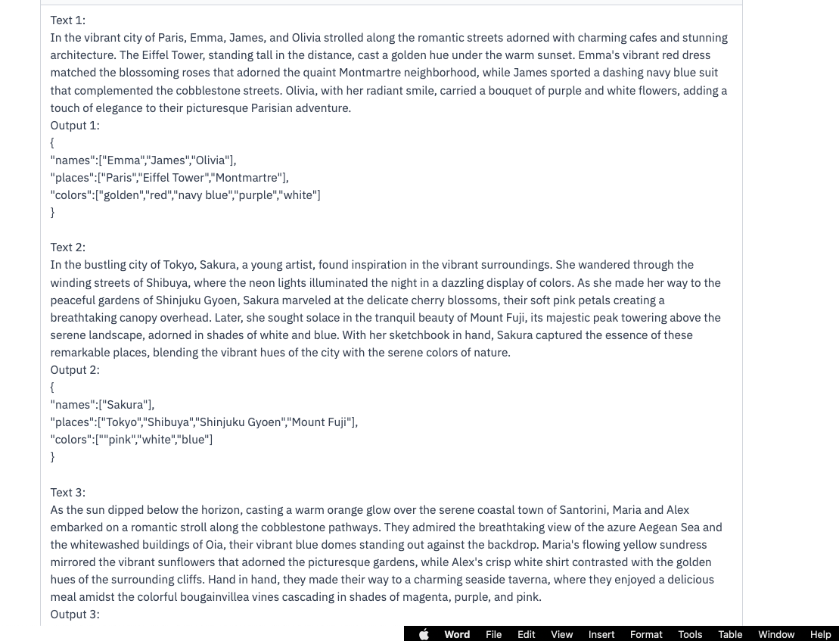

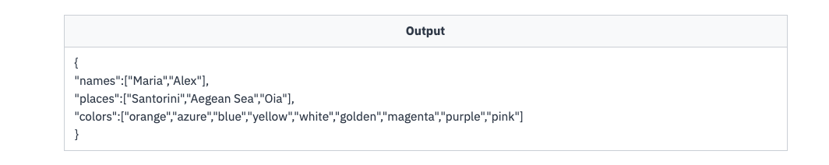

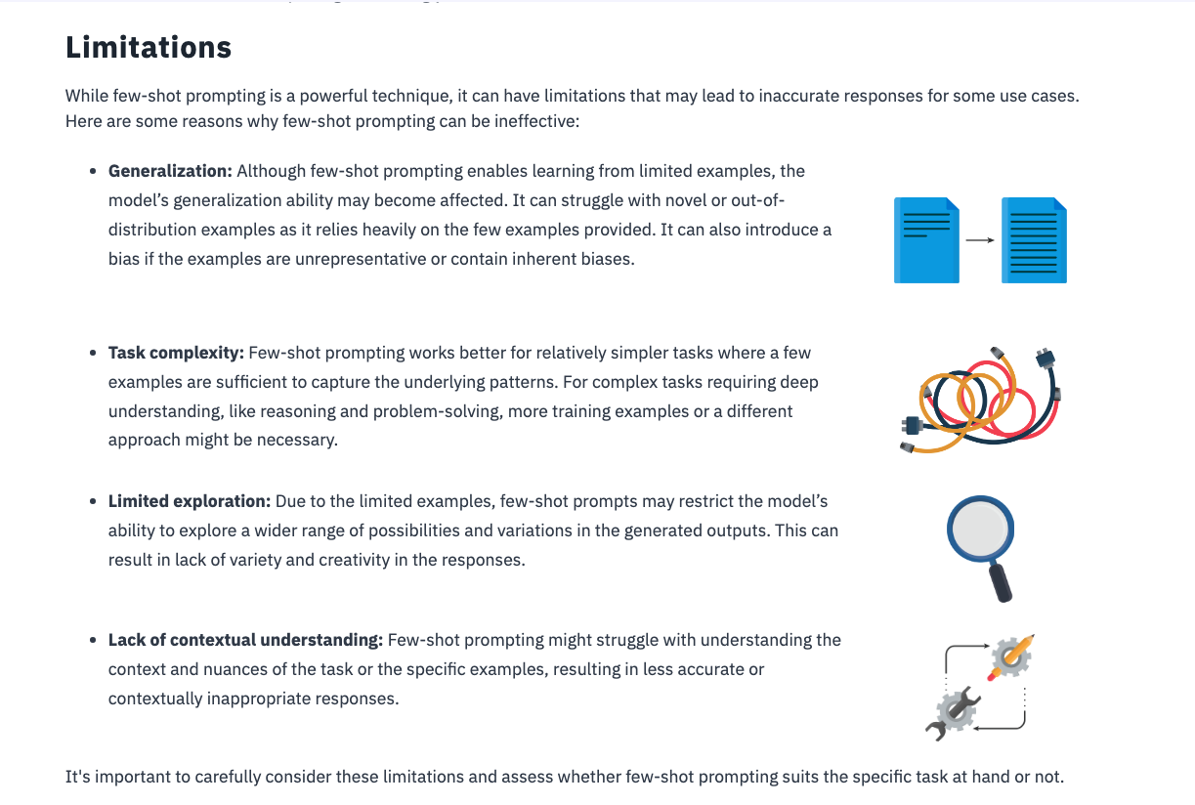

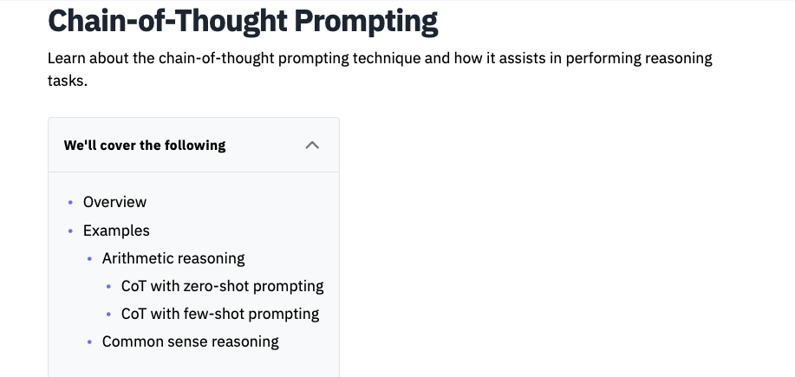

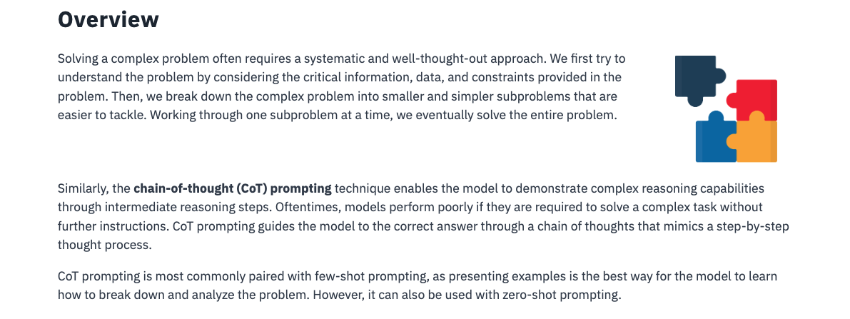

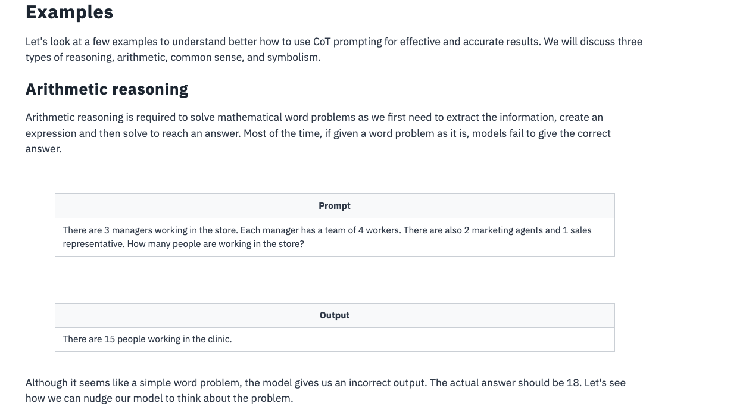

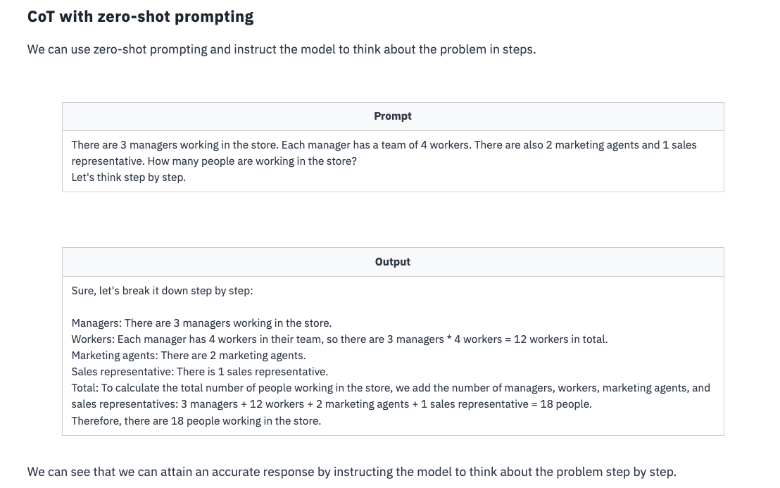

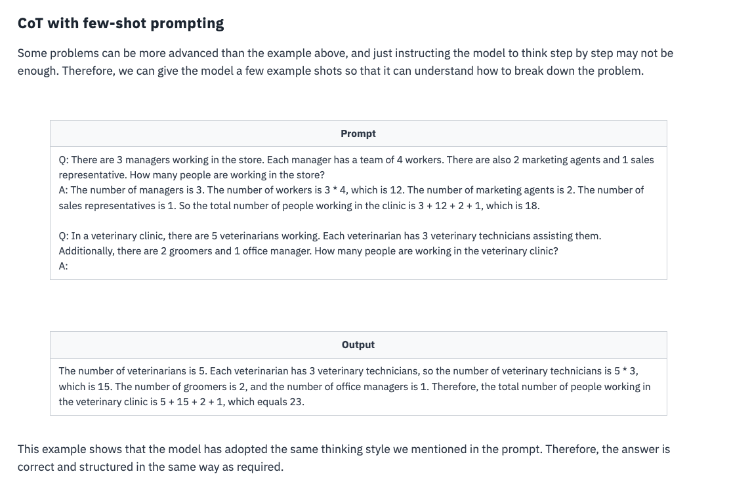

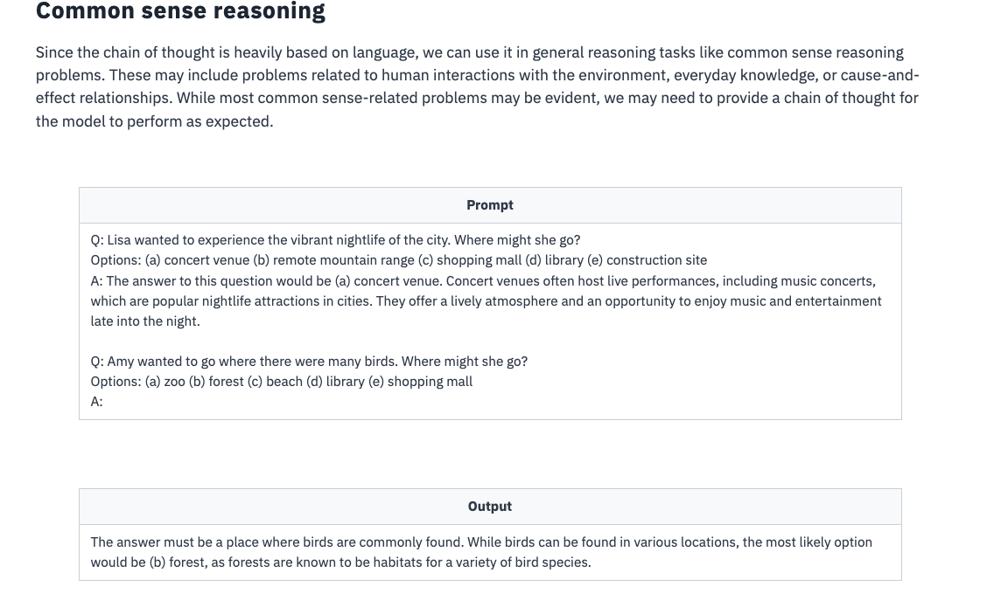

QUIZ:

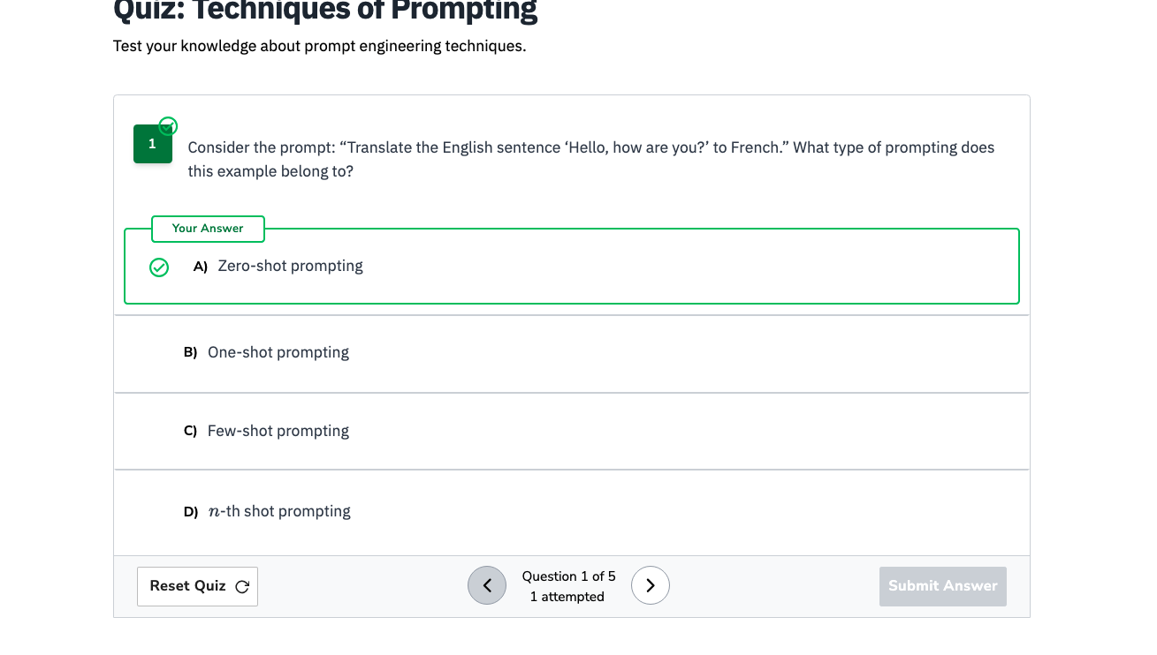

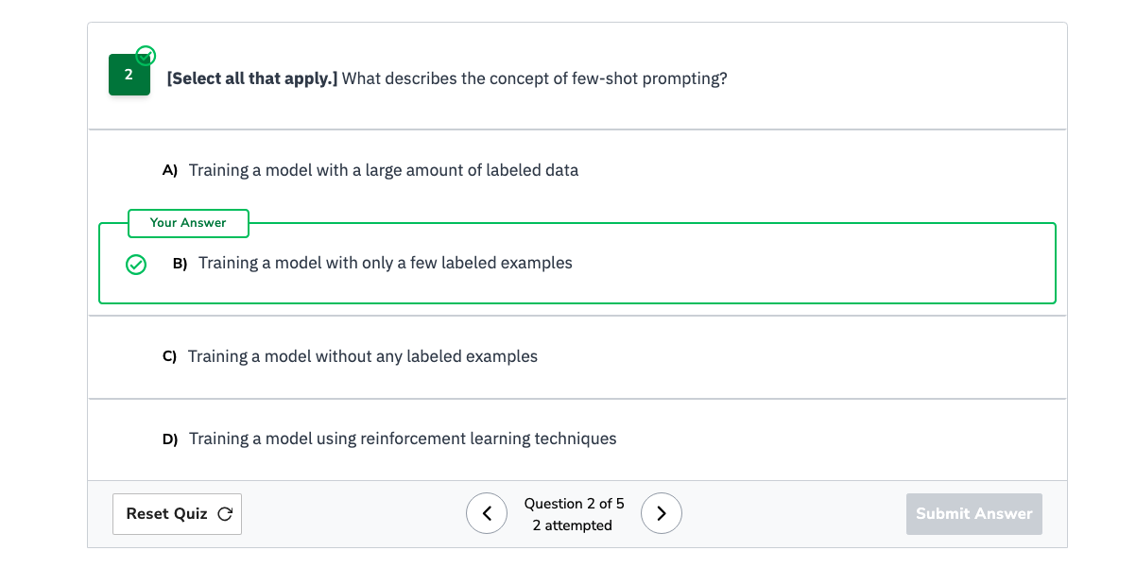

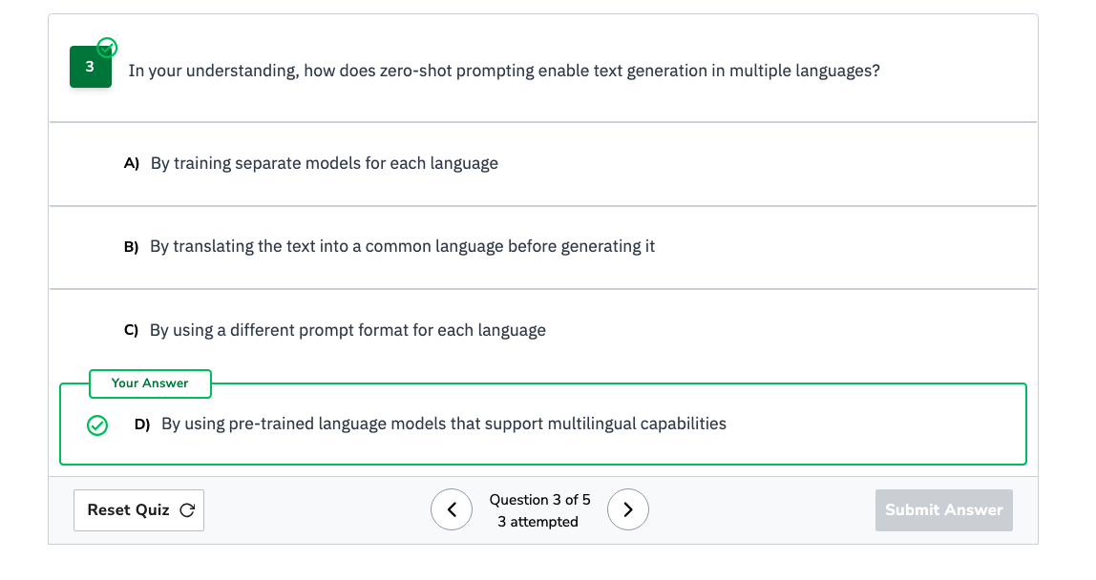

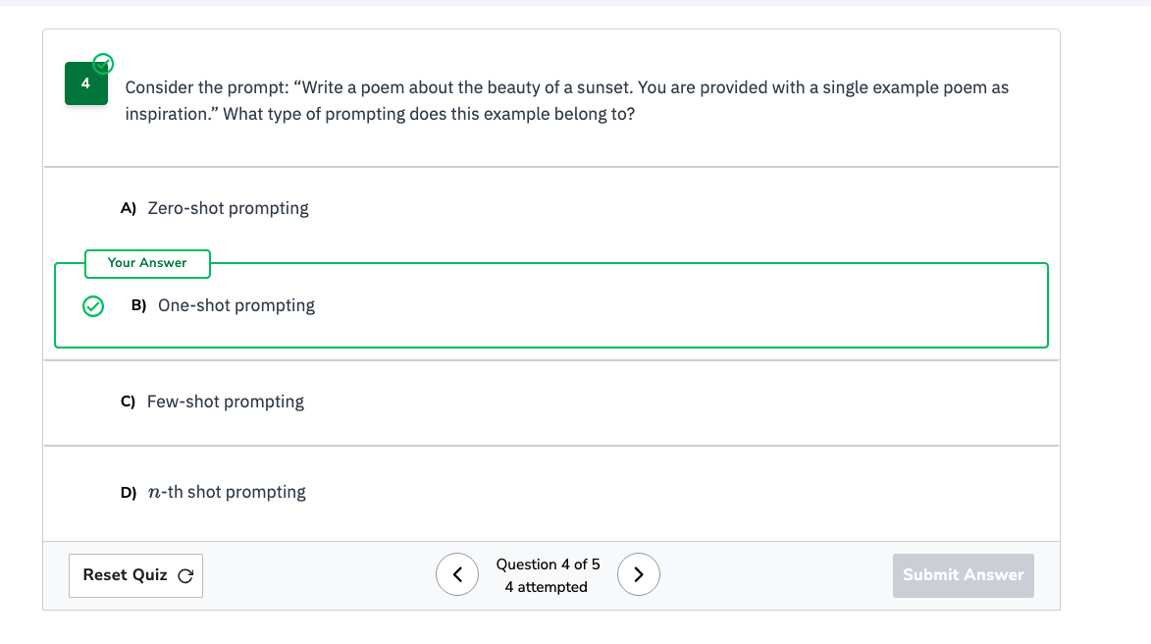

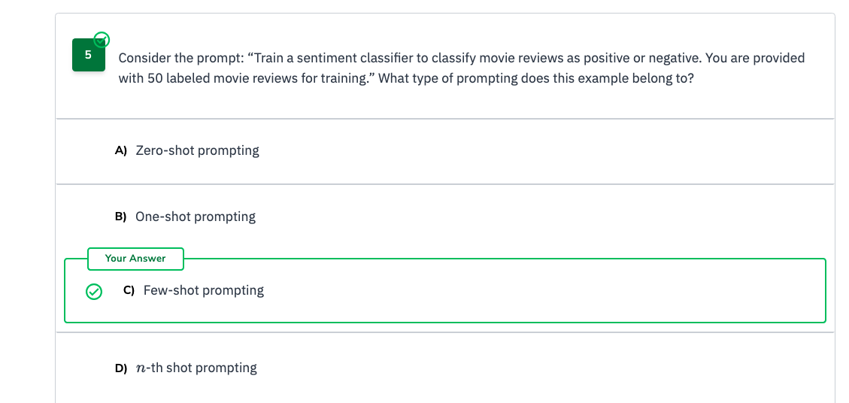

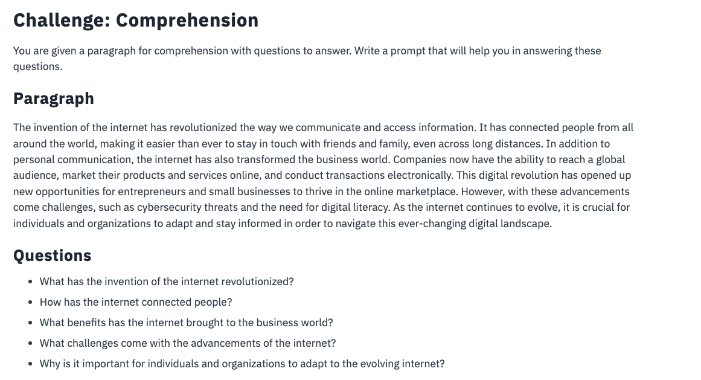

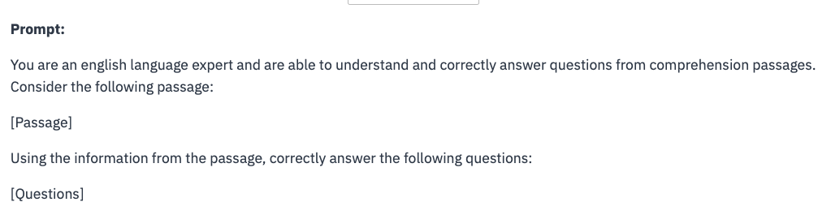



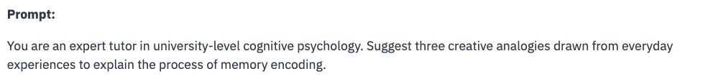

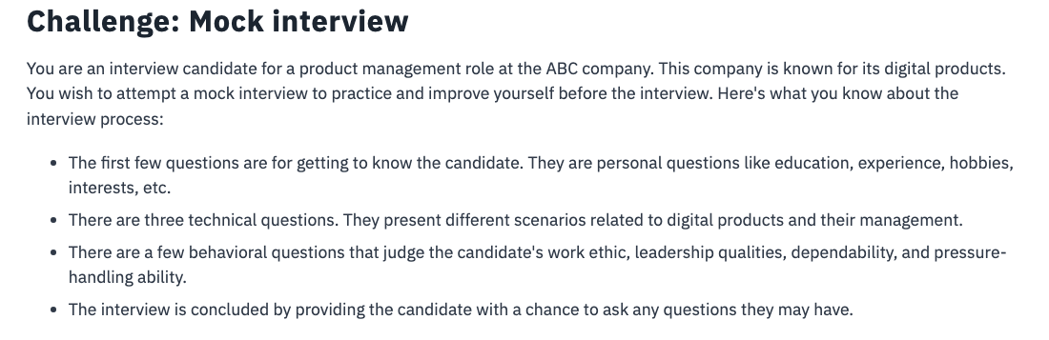

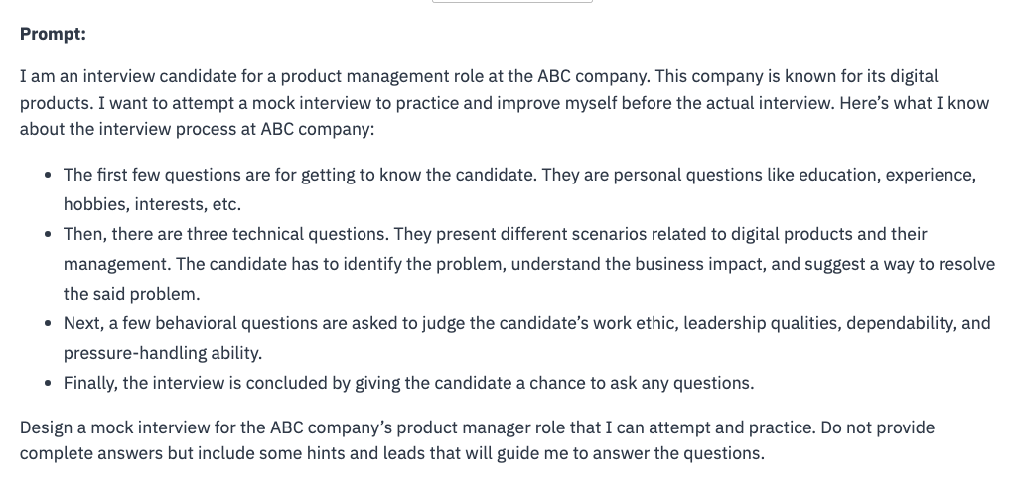

**How students can use prompt engineering:**

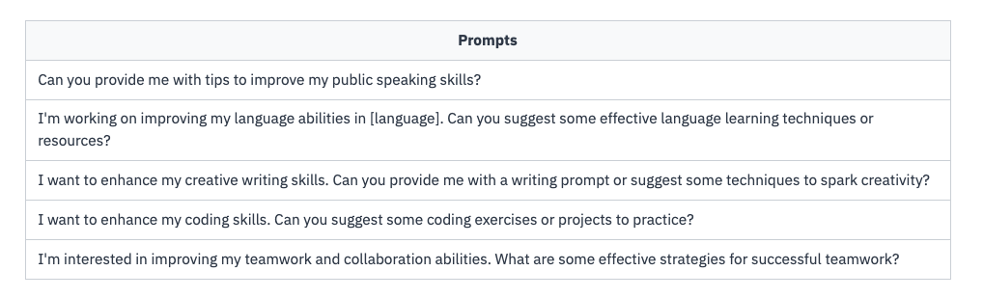

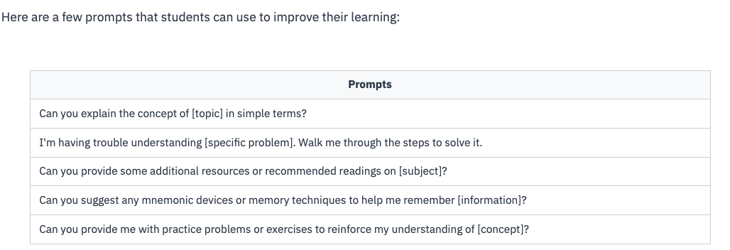

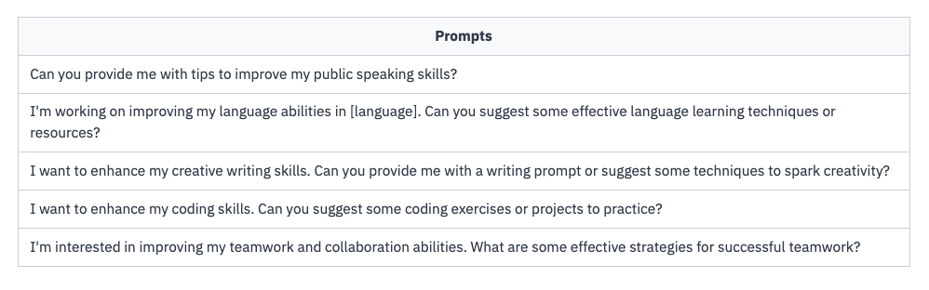

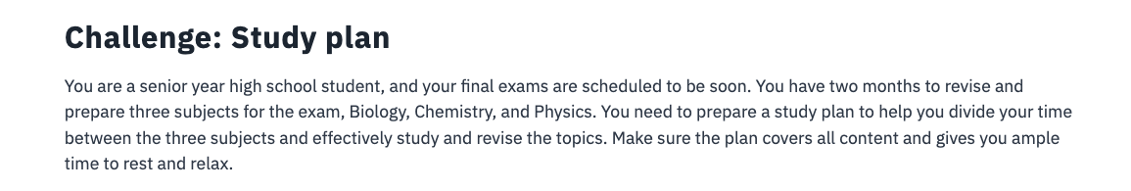

My Answer:

I am an senior year high school student and my exams are scheduled soon. I have two months to revise and prepare three subjects for the exam. The subjects are Biology, Chemistry, and Physics. Can you provide me with a two months study plan that can divide my time between these three subjects mentioned. The study plan should be effective and covers all content and also consider to spare ample time for rest and relax.

Educative answer:

I am a senior year high school student, and my final exams are scheduled to be soon. I have two months to revise and prepare three subjects for the exam, Biology, Chemistry, and Physics. I need to prepare a study plan to help me divide my time between the three subjects and effectively study and revise the topics.  
Create a two-month study plan that covers all the content and gives me ample time to rest and relax.

**Parenting Aid:**

Below are some prompts that parents can use to ask questions, seek guidance and receive suggestions:

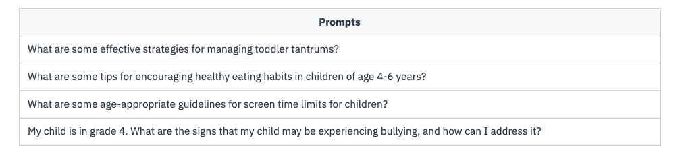

**Educational support**

## Engaging activities

## 

## Personal development

## 

**Challenge: Bedtime story**

As a parent of a 4-year old, you want to introduce a bedtime story habit in your child. You want to read age-appropriate bedtime stories with a moral that children can learn. The story should have at least a five-minute read time.

**My Answer:**

I am a parent of a 4 year old and want to introduce bedtime story habit in my child. Could you generate a bedtime story with a moral that children can learn and the story should be age-appropriate and is at least a five-minutes read time.

## Solution:

As a parent of a 4-year old, I want to read bedtime stories to my child.  
Generate a bedtime story that has at least a five-minute read time. The moral of the story should be impactful and encourage the child to do good in their life. Make the story engaging and interesting to read.

# Social Media: YouTuber, Twitter Influencer, Instagram Influencer

## Creating content

## 

## Building a community

## 

## Expanding influence

## Dealing with criticism

## 

## 

## My Answer:

I am a popular and successful social media influencer. Recently I noticed that the algorithm of my account has significantly decreased in reach and engagement of my posts. Could you help me with new strategies with innovative approaches to ensure my content continues to reach and resonate with my audience effectively. Below are some strategies that I want to explore:

Alternative content formats

Engagement techniques

Data analytics and insights to understand the audience

## Solution:

As a successful social media influencer, I’ve recently experienced a decrease in reach and engagement due to algorithm changes. I want to adapt to these changes and find new strategies to ensure my content continues to reach and resonate with my audience effectively. Help me brainstorm innovative approaches and adapt my content strategy to overcome these challenges. I want to explore alternative content formats, engagement techniques, or approaches that can maintain and grow my audience despite the algorithm changes. I also want to leverage data analytics and insights to understand my audience’s preferences better and adapt my content accordingly.

It’s important to me that I stay true to my personal brand throughout this process. Please provide me with creative ideas, actionable insights, and practical advice that can help me navigate the algorithm changes and optimize my content strategy for continued success.

**Freelancers**

### Job opportunities

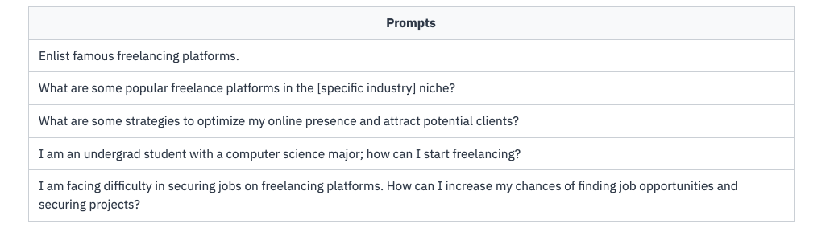

### Time management

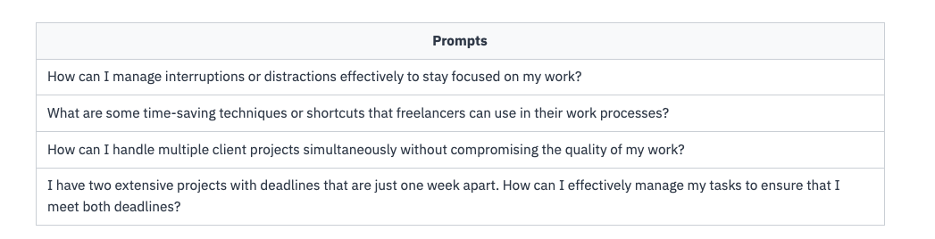

### Professional advice

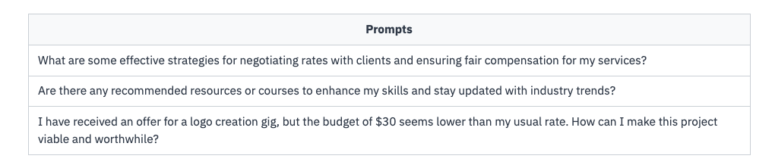

## Challenge: Selecting job offers

The freelancer, Alex, is an experienced graphic designer specializing in branding and logo design. Alex has built a strong reputation in the industry and consistently delivers high-quality work. Due to their expertise and impressive portfolio, Alex has attracted the attention of three potential clients, each offering exciting opportunities.

**Job offer 1: Rebranding project**Company A, a well-established organization, seeks a comprehensive strategy. The project involves creating a new logo, designing marketing collateral, and revamping their website. The client emphasizes the importance of capturing the essence of their brand identity and attracting a younger target audience.

**Job offer 2: Logo design and branding**Startup B is a promising tech startup needing a compelling logo and branding materials. The project includes creating a captivating brand identity that resonates with its target market. The client seeks a modern, innovative design reflecting their company's core values and vision.

**Job offer 3: Non-profit organization event campaign**Non-profit organization C is organizing a fundraising event and requires a captivating event campaign. The project involves designing promotional materials, including posters, banners, and social media graphics. The client emphasizes creating visually appealing content to engage and inspire their audience.

Create a prompt that will guide Alex help to select two jobs.

My answer:

Alex is a freelancer and has an experience in graphic designer specializing in branding and logo design. Due to their expertise and impressive portfolio, Alex got an offer from below three companies each offering exciting opportunities and is confused . Alex has to shortlist 2 job offers from the below three jobs: Job offer 1: Rebranding project

Company A, a well-established organization, seeks a comprehensive strategy. The project involves creating a new logo, designing marketing collateral, and revamping their website. The client emphasizes the importance of capturing the essence of their brand identity and attracting a younger target audience.

Job offer 2: Logo design and branding

Startup B is a promising tech startup needing a compelling logo and branding materials. The project includes creating a captivating brand identity that resonates with its target market. The client seeks a modern, innovative design reflecting their company's core values and vision.

Job offer 3: Non-profit organization event campaign

Non-profit organization C is organizing a fundraising event and requires a captivating event campaign. The project involves designing promotional materials, including posters, banners, and social media graphics. The client emphasizes creating visually appealing content to engage and inspire their audience.

Advice which two job offers Alex should select.

Solution:

Alex is an experienced freelance graphic designer specializing in branding and logo design. Alex has built a strong reputation in the industry and consistently delivers high-quality work. Due to his expertise and impressive portfolio, Alex has attracted the attention of three potential clients, each offering exciting opportunities. Alex has to shortlist two of the following three jobs.

**Job offer 1: Rebranding project**  
A well-established company is rebranding and requires Alex to dedicate time to creating new logos, revamping, and marketing while reflecting their core values.

**Job offer 2: Logo design and branding**  
A promising startup requires Alex to create a captivating brand identity and be modern and innovative.

**Job offer 3: Non-profit organization event campaign**  
A non-profit organization requires Alex to design the campaign for a fundraising event, including promotional materials, banners, posters, and social media graphics.

Suggest which two job offers Alex should select by analyzing the costs and benefits.

# Spreadsheet Expert

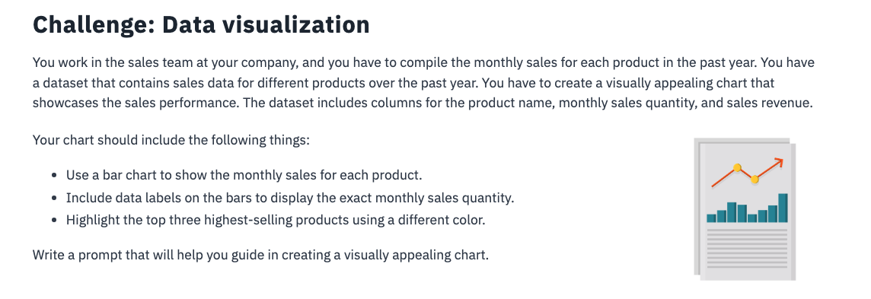

My answer:I work in a sales team at a company. I want to create an appealing chart showcasing the sales performance that compiles the monthly sales for each product from the dataset that contains sales data for different products for the last year. The dataset includes columns for the product name, monthly sales quantity and sales revenue. The chart should include the following:

Use a bar chart to show the monthly sales for each product.

Include data labels on the bars to display the exact monthly sales quantity.

Highlight the top three highest-selling products using a different color.

Could you help me on creating the chart in speadsheet?

Solution:

I have a dataset containing sales data for different products over the past year that includes columns for the product name, monthly sales quantity, and sales revenue. I want to create a visually appealing bar chart using the XYZ spreadsheet software that shows each product’s monthly sales quantity.

Here is some important information to consider:

* I want to include data labels on the bars to display each month’s sales quantity value.
* I want to highlight the top three products with the highest total sales using a different color.

Can you guide me on creating this chart in my spreadsheet software?

# Empowering Advertisers